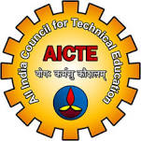 | AICTE-ISTE Sponsored One Week (Online)  INDUCTION / REFRESHER PROGRAM  on  Advanced Training Program on Teaching  (Phase - III)  6th – 12th April, 2021 | 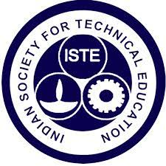

INDEX
1 | About the Institution
2 | Mission and Vision  - Institution  - Department
3 | About the INDUCTION PROGRAM
4 | Committee List
5 | Constitution of Program Evaluation Committee  Minutes of Meeting - PEC
6 | Program Brochure
7 | Program Schedule
8 | Day wise Report
9 | List of Participants
10 | Test Question
11 | List of Qualified Participants for Receiving the Certificate.
12 | Brief Report on INDUCTION PROGRAM
13 | INDUCTION PROGRAM Completion Report
14 | Feedback from Participants

Acknowledgement
The committee wishes to express its appreciation and thanks to All India Council for Technical Education (AICTE) & Indian Society for Technical Education (ISTE) for sanctioning and sponsoring this Induction / Refresher Program on “Advanced Training Program on Teaching”. This sponsorship enabled the organising committee to arrange this program in the most proper and suitable way for our participants. The committee also thank the help extended by many in organising this program and it is not possible to name all them here.

The Committee Members

_______________________________  Dr. G.CHARLES BABU  (Member Secretary) | _____________________________  Dr. R.P.RAM KUMAR  (Member)
_____________________________  Dr. S. MADHU BABU  (Member) | _____________________________  Dr.N LAKSHMIPATHI ANANTHA  (Member)
_____________________________
Dr. Dr. A. RAVEENDRA
(Chairperson)

About the Institution
Malla Reddy Engineering College (Autonomous) is a fulfilment of the distinct vision of its founder Chairman, Mr. Ch. Malla Reddy, the present MLA, Medchal Constituency and Hon'ble Minister Labour & Employment, Factories, Women & Child Welfare and Skill Development, Telangana State. MREC (A) is one of the premier Engineering Colleges in the State of Telangana, established in the year 2002, approved by AICTE and affiliated to JNTUH, Hyderabad. The institute is accredited by NAAC with 'A’ Grade (II cycle). It has been conferred upon the Autonomous status by the JNTUH in the year 2011 and subsequently by the UGC, in the year 2014. MREC (A) is established with the aim of providing high quality technical education through constant innovation and academic excellence. It offers B. Tech. Programs in the disciplines of CE, EEE, Mech., ECE, CSE, IT & Mining Engineering besides five M. Tech. Programs with SE, EPS, TE, MD & CSE specializations and MBA. MREC (A) has an impressive on-campus recruitment record with many leading corporate regularly visiting and recruiting students.
About the Department
The Department of Computer Science and Engineering was established in 2005 with specific vision, mission and goals. As the college is affiliated to Jawaharlal Nehru Technological University, Hyderabad (JNTUH) and recognized by AICTE New Delhi, the department works under the rules and regulations of above-mentioned bodies. The college has got Autonomous Status in 2011-12. The course curriculum is designed and developed by the autonomous college under the guidelines of JNTUH. The Department implements effective Teaching – Learning methodologies and their Evaluation procedures as per the guide lines of JNTUH, AICTE, College Academic Council (CAC) and Department Advisory committee (DAC). Excellent infrastructural facilities and state of the art labs have been established.
To support and guide the students for their progress mentoring and counselling methodologies are being implemented. Quality improvement programs like refresher courses, seminars, workshops and conferences are being conducted for Faculty, Technical Staff and Students. Various coordination committees have been formed to develop the leadership qualities both in faculty and students which proved to be very effective in the administration of the department.

Vision and Mission

Vision of the Institute
To be a premier center of professional education and research, offering quality programs in a socio-economic and ethical ambience.

Mission of the Institute
- To impart knowledge of advanced technologies using state-of-the-art infrastructural facilities.
- To inculcate innovation and best practices in education, training and research.
- To meet changing socio-economic needs in an ethical ambiance.

Vision of the Department
To attain global standards in Computer Science and Engineering education, training and research to meet the growing needs of the industry with socio-economic and ethical considerations.

Mission of the Department
- M1- To impart quality education and research to undergraduate and postgraduate students in Computer Science and Engineering.
- M2-To encourage innovation and best practices in Computer Science and Engineering utilizing state-of-the-art facilities.
- M3-To develop entrepreneurial spirit and knowledge of emerging technologies based on ethical values and social relevance.

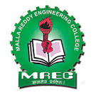 | MALLA REDDY ENGINEERING COLLEGE (AUTONOMOUS)  MAISAMMAGUDA, DHULAPALLY (POST VIA KOMPALLY), SECUNDERABAD – 500100 | 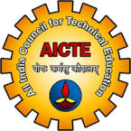
DEPARTMENT OF COMPUTER SCIENCE AND ENGINEERING
AICTE – ISTE Sponsored One Week (Online)
INDUCTION / REFRESHER PROGRAM on
“Advanced Training Program on Teaching (Phase - I)”
6th – 12th April, 2021

ABOUT THE PROGRAM

About ACTE - ISTE
AICTE promotes the quality in teaching, plans and coordinates the development of technical education system ad regulates and maintains the norms and standards.
The Indian Society for Technical Education (ISTE) empowers the career development of teachers and personality development of students and overall development of our technical education system.
AICTE and ISTE jointly sponsoring for Induction / Refresher programme to help the faculty members to update their knowledge, skills and providing an opportunity for interaction and mutual exchange with resource persons identified from industries and renowned institutes having expertise I particular areas of specialization.

Objective:
  - To train teachers to use pedagogy methods which will lead
  - To achieve outcome-based education.
  - To train the teacher to use innovative methodologies in content delivery like flip the class, video lectures, think pair share etc.
  - To train the teachers to use novel methods in laboratory courses for engaging students e.g., use of Latex.
  - To train the teachers to use novel methods for assessment of student learning
  - To discuss the necessity methodology and Proforma of Accreditation.
The Major Course Contents:

- Significance of teaching engineering
- Teaching methods and styles – pedagogy
- Designing the course contents
- Evaluation and assessment
- Role of an engineering teacher
- Outcome based education and its implementation
- Stress management

MALLA REDDY ENGINEERING COLLEGE (AUTONOMOUS)
MAISAMMAGUDA, DHULAPALLY (POST VIA KOMPALLY), SECUNDERABAD – 500100
DEPARTMENT OF COMPUTER SCIENCE AND ENGINEERING
AICTE – ISTE Sponsored One Week (Online)
INDUCTION / REFRESHER PROGRAM on
“Advanced Training Program on Teaching (Phase - III)”
6th – 12th April, 2021

COMMITTEE

Sl.No. | Committee | Staff
1 | Registration | Dr.G.Charles Babu  Dr. N Lakshmipathi Anantha
2 | Attendance & Certificate | Dr. M. Swami das  Dr. P. Srinivas
3 | Finance | Dr.R.P.Ram Kumar
4 | AICTE – ISTE Formalities | Dr. G.Charles Babu
5 | Inauguration and Valediction | Dr. M. Swami das
6 | Feedback | Mr. Rakesh Reddy
7 | Banner (Designing, Printing, Fixing) | Mr. Gouri Sainath
8 | Brochure & Invitation | Dr. Shaik Jakeer Hussain
9 | Hall Arrangement  (Systems , A/V, Special Requirement) | Mr. P. Praveen Kumar

HoD-CSE

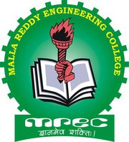
MALLA REDDY ENGINEERING COLLEGE (AUTONOMOUS)
Maisammaguda, Dhulapally(post via Kompally), Secunderabad – 500100

MR/Apr/2021/PEC/01 01-04-2021
NOTIFICATION
Sub: | Constitution of committee to monitor and evaluate the AICTE- ISTE sponsored INDUCTION/ REFRESHER PROFRAM on “Advanced Training Program on Teaching”
Ref: | ISTE/AICTE-ISTE Orientation/ Refresher Program/2018-19

As per the direction of All India Council for Technical Education and Indian Society for Technical Education to monitor and evaluate the AICTE- ISTE Sponsored INDUCTION/ REFRESHER PROGRAM on “Advanced Training Program on Teaching” has been constituted with the following members.
S.No | Name | Designation
1 | Dr. A. Raveendra,  Principal, MREC (A), Secunderabad. | Chairperson
2 | Dr. G. Charles Babu,  Professor, CSE, MREC (A), Secunderabad. | Member Secretary
3 | Dr. N Lakshmipathi Anantha,  Professor & HoD, CSE, MREC (A), Secunderabad. | Member
4 | Dr. S. Madhu Babu,  Professor & HoD, ECE, MREC (A), Secunderabad. | Member
5 | Dr. R. P. Ram Kumar,  Professor, CSE, MREC (A), Secunderabad. | Member

As the committee shall review the program, conduct a test and submit the minutes of the meeting along with the PEC report within a week after the completion of the program.

PRINCIPAL
Copy to:-
- Director
- Principal
- All HoD’s
- All Concerned Members

MALLA REDDY ENGINEERING COLLEGE (AUTONOMOUS)
MAISAMMAGUDA, DHULAPALLY (POST VIA KOMPALLY), SECUNDERABAD – 500100
DEPARTMENT OF COMPUTER SCIENCE AND ENGINEERING
AICTE – ISTE Sponsored One Week (Online)
INDUCTION / REFRESHER PROGRAM on
“Advanced Training Program on Teaching (Phase - III)”
6th – 12th April, 2021

Minutes of Meeting-I

Convenor of the meeting | Principal
Members Present | Dr. A. Raveendra  Dr. G. Charles Babu,  Dr. N Lakshmipathi Anantha,  Dr. S. Madhu Babu,  Dr. R. P. Ram Kumar.
Date of Meeting | 01.04.2021
Time of Meeting | 02:00PM
Venue | Conference Room

Agenda:
- Fixing the Program Dates
- Resource Person
- Formation of Committee list
- Budget
- Test Questions and Performance evaluation

S.No | Points Discussed | Target Date | Responsibilities
1 | The roles and responsibility of PEC is discussed and finalized. Program planning, implementation and evaluating the activities of the Program | - | PEC- Chairperson
2 | Date for the conduction of the INDUCTION/ REFRESHER Program is discussed and finalized. | Immediate | PEC
3 | The proposed date of the INDUCTION/ REFRESHER Program is planned during 06-04-2021 to 12-04-2021. | Immediate | PEC
4 | List of the Various Committees and its responsibilities were discussed. | 03-04-2021 | HoD and Program Coordinator
5 | ISTE-AICTE-ISTE Orientation INDUCTION/ REFRESHER Program/2018-19 | - | Program Coordinator and finance committee
6 | Resource Person for the Program has been identified in this meeting. | - | HoD and Program Coordinator
7 | Question Paper for the test should be prepared by the subject expert in consultation with the resource person. | 05-04-2021 | Dr. M. Swami Das
8 | Conducting the test and evaluation the performance of the participants should be done by PEC.  Test Date: 12-04-2021 | 12-04-2021 | PEC

Prepared by Dr. G. Charles Babu, Professor, CSE

PRINCIPAL
Copy to:
- AICTE & ISTE
- Management
- File

MALLA REDDY ENGINEERING COLLEGE (AUTONOMOUS)
MAISAMMAGUDA, DHULAPALLY (POST VIA KOMPALLY), SECUNDERABAD – 500100
DEPARTMENT OF COMPUTER SCIENCE AND ENGINEERING
AICTE – ISTE Sponsored One Week (Online)
INDUCTION / REFRESHER PROGRAM on
“Advanced Training Program on Teaching (Phase - III)”
6th – 12th April, 2021

Minutes of Meeting- II
Convenor of the meeting | Principal
Members Present | Dr. A. Raveendra  Dr. G. Charles Babu,  Dr. N Lakshmipathi Anantha,  Dr. S. Madhu Babu,  Dr. R. P. Ram Kumar
Date of Meeting | 13.04.2021
Time of Meeting | 2:00PM
Venue | Conference Room

Agenda:
- Test evaluation
- Distribution of Certificates

S.No | Points Discussed | Target Date | Responsibilities
1 | Test was conducted and the performance of the participants was discussed. | 13.04.2021 | PEC
2 | The final list of participants who successfully completed the programme and qualified in the test is declared in the meeting. |  | PEC
3 | Participants feed-back is reviewed and discussed. The scope for further improvement is also reviewed based on the feed-back. |  | HoD and Program Coordinator
Prepared by Dr. G. Charles Babu, Professor, CSE
PRINCIPAL
Copy to:
- AICTE & ISTE
- Management
- File
MALLA REDDY ENGINEERING COLLEGE (AUTONOMOUS)
MAISAMMAGUDA, DHULAPALLY (POST VIA KOMPALLY), SECUNDERABAD – 500100
DEPARTMENT OF COMPUTER SCIENCE AND ENGINEERING
AICTE – ISTE Sponsored One Week (Online)
INDUCTION / REFRESHER PROGRAM on
“Advanced Training Program on Teaching (Phase - III)”
6th – 12th April, 2021

Day & Date | Session 1  (10.00 AM – 11.30 AM) | Break | Session 2  (11.40 AM – 01.00 PM) | Lunch | Session 3  (2.00 PM – 3.30 PM)
Day - 1  06-04-2021  Tuesday | INAUGURATION |  | Dr. G Rajesh Kumar  Exploring Techniques of Video Capturing and Editing Tools for Blended Learning |  | Dr. More Swami Das  Effective and Innovating Teaching and Learning Methods
Day - 2  07-04-2021  Wednesday | Dr. K. R. Ananth  Teaching Strategies to Facilitate Active Learning |  | Dr. S. Kayalvili  Outcome based Education |  | Dr. Latha Jothi  Creating a Learner Centric MOOC
Day - 3  08-04-2021  Thursday | Dr. S Viswanadha Raju  Difference Between Knowledge and Skills, Blooms Taxonomy |  | Dr. S. Jabeen Begum,  Video Content Creation Tools |  | Dr. K. Venugopal Rao,  Active Learning Strategies – A Pedagogical Perceptive & Innovative Methods of Teaching
Day - 4  09-04-2021  Friday | Dr. S Viswanadha Raju  Assessment Tools  (OBE – Best Practices) |  | K. Vijaya  Quantitative and Qualitative Measures in Education |  | Dr. D. Prabakar  Advance Training Program on Teaching
Day - 5  10-04-2021  Saturday | Dr T V Rajini Kanth,  Motivating the Students to Work up to Full Potential for Success in Engineering Study |  | Dr. R. P. Ram Kumar,  Flipped Learning Objectives |  | Dr. KV Subba Raju  Flipped Learning : An Effective Method for Classroom Management
Day - 6  12-04-2021  Monday | Dr. T. Mohanapriya  Teachers as Learners |  | Dr. Deepa Jananakumar  Integrating Innovation and Teaching Strategies in the Traditional Classroom |  | VALIDICTORY

HoD Coordinator Principal
MALLA REDDY ENGINEERING COLLEGE (AUTONOMOUS)
MAISAMMAGUDA, DHULAPALLY (POST VIA KOMPALLY), SECUNDERABAD – 500100
DEPARTMENT OF COMPUTER SCIENCE AND ENGINEERING
AICTE – ISTE Sponsored One Week (Online)
INDUCTION / REFRESHER PROGRAM on
“Advanced Training Program on Teaching (Phase - III)”
6th – 12th April, 2021

Day-wise Report

DAY: 1 - (06.04.2021)
Inauguration Started at 10AM to 11:30 AM
On behalf of Malla Reddy Engineering College (Autonomous), Hyderabad management, secretary, director sir, principal sir, coordinator of this program, chief guest, and guest of honour. We welcome all the participants for AICTE /ISTE sponsored one-week online Induction /Refresher program on “Advanced Training Program on Teaching”
Special thanks to AICTE/ISTE for sponsoring the program
Chief Guest; Dr. G. Venkata Subbaiah, Professor and Head, MVSR Engineering college, Executive council member of ISTE, New Delhi
Guest of Honour: Dr. S. Vishwanatha Raju, Professor and Vice Principal, JNTUH Jagtial, Karimnaga.

Day1: Session 2: 11.40 AM to 01.00 PM
Session by Dr. G Rajesh Kumar, Associate Professor, VNRVJIET, Hyderabad
Topics Covered: Exploring Techniques of Video Capturing and Editing Tools for Blended Learning
Blended learning strategy allows you to teach your students in a way that allows them to learn in a much more practical way. The Traditional teaching methods mean you have to accommodate your lesson plan for both types of students: Ones who can grasp the topic quickly and those who need a little help in understanding, added to the flipped classroom model, which is a derivative of blended learning, with quizzes, you can gauge where your students are in the lesson and assign work based on their progress.
Day1: Session 3: 2.00 PM to 3.30 PM
Session by Dr. More Swami Das, Professor, MREC (A), Hyderabad
Topics Covered: Effective and Innovating Teaching and Learning Methods
Effective and Innovating Teaching and Learning Methods, to explain the find evidence and examples, generalize, apply analogies and represent a topic in a new way. Now the traditional way of teaching and learning has been transformed into interaction-based learning which is increasing the effectiveness of the whole learning process for the students of primary, as well as higher education.

DAY: 2 - (07.04.2021)
Day2: Session 1: 10.00 AM to 11.30 AM
Session by Dr. K. R. Ananth, Professor, MCA, VCET, TN
Topics Covered: Teaching Strategies to Facilitate Active Learning
Active learning engages students in learning, using activities such as reading, writing, discussion, or problem solving, which promote analysis, synthesis, and evaluation of class content. Active learning techniques include role-playing, case studies, group projects, think-pair-share, peer teaching, debates, Just-in-Time Teaching, and short demonstrations followed by class discussion.
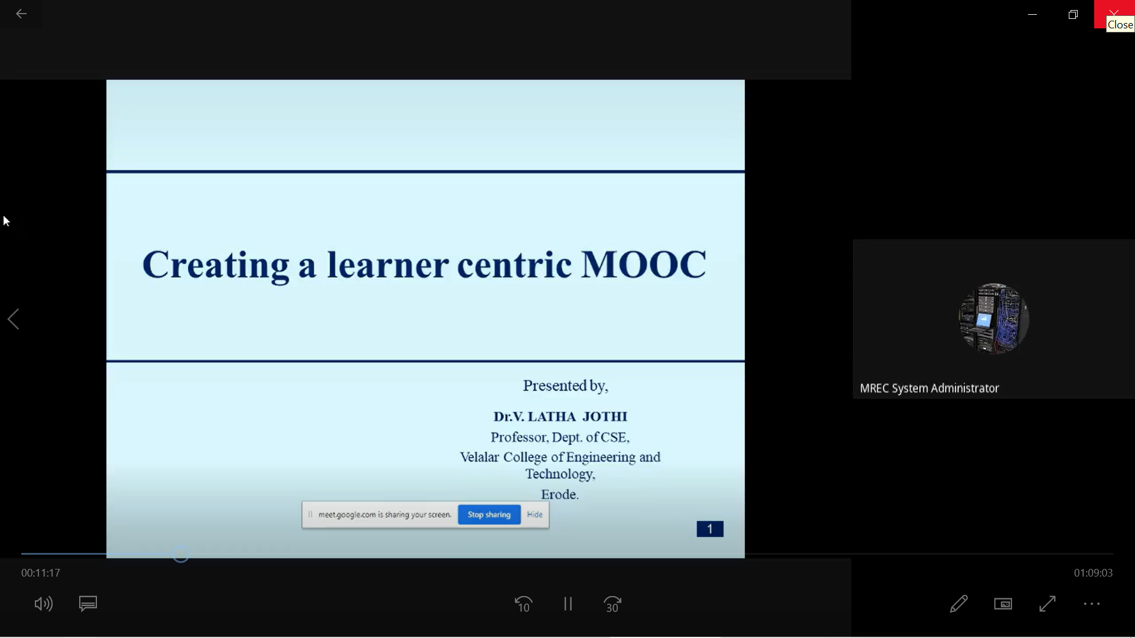

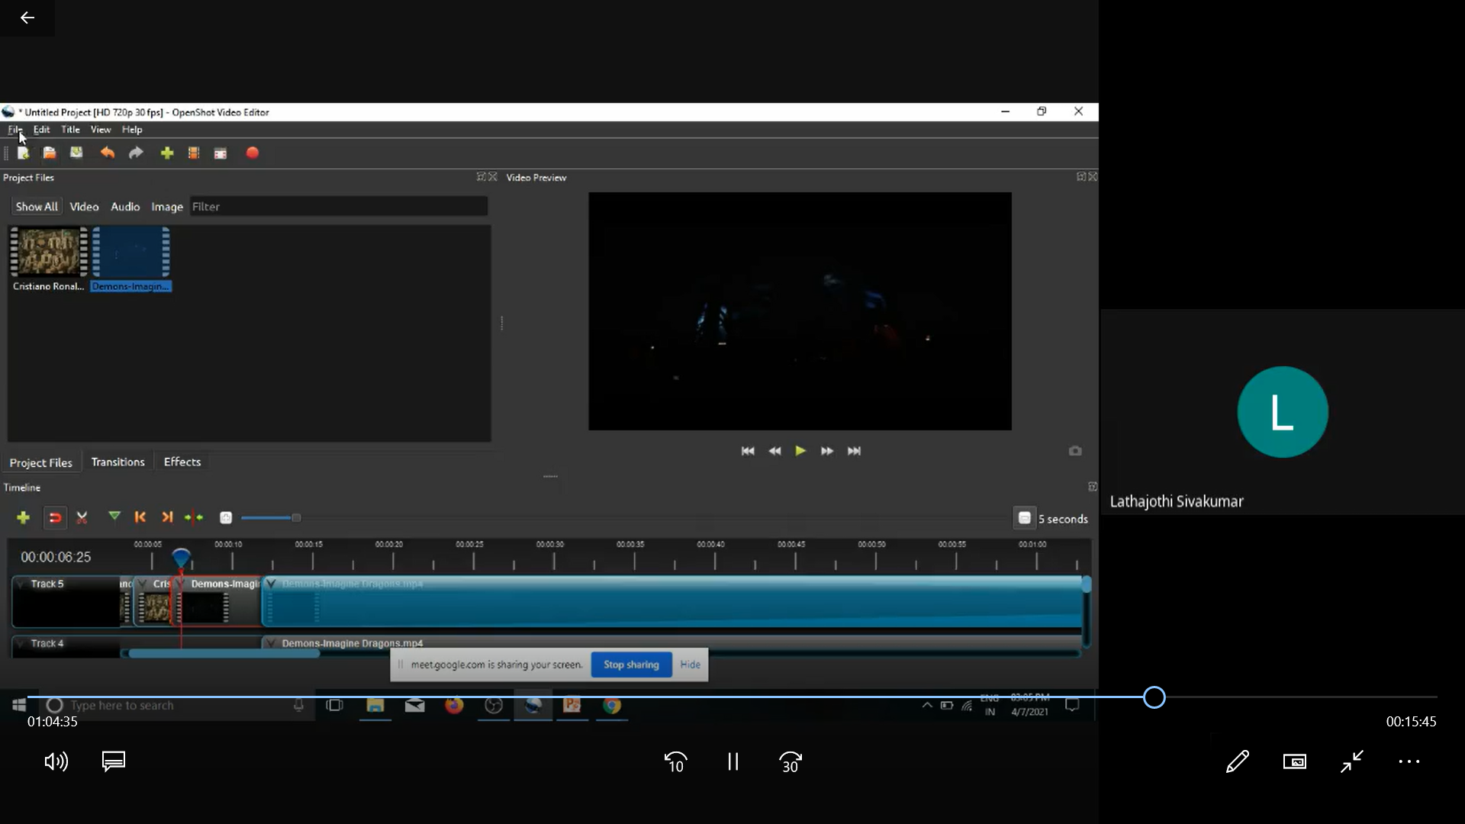
Day2: Session 2: 11.40 AM to 01.00 PM
Session by Dr. S. Kayalvili, Professor, CSE, VCET, TN
Topics Covered: Outcome based Education
Outcome based education or OBE is a student-centric educational model that maps & measures students' performance at every step. The OBE model aims to maximize student learning outcomes by developing their knowledge & skills.

Day2: Session 3: 2.00 PM to 3.30 PM
Session by Dr. Latha Jothi, Professor, CSE, VCET, TN
Topics Covered: Creating a Learner Centric MOOC
The learner-centric model greatly motivates the learner and has a positive impact on the learning process. The course provided a practical approach in developing, designing and running a MOOC as per the real need of enriching the learning experience.

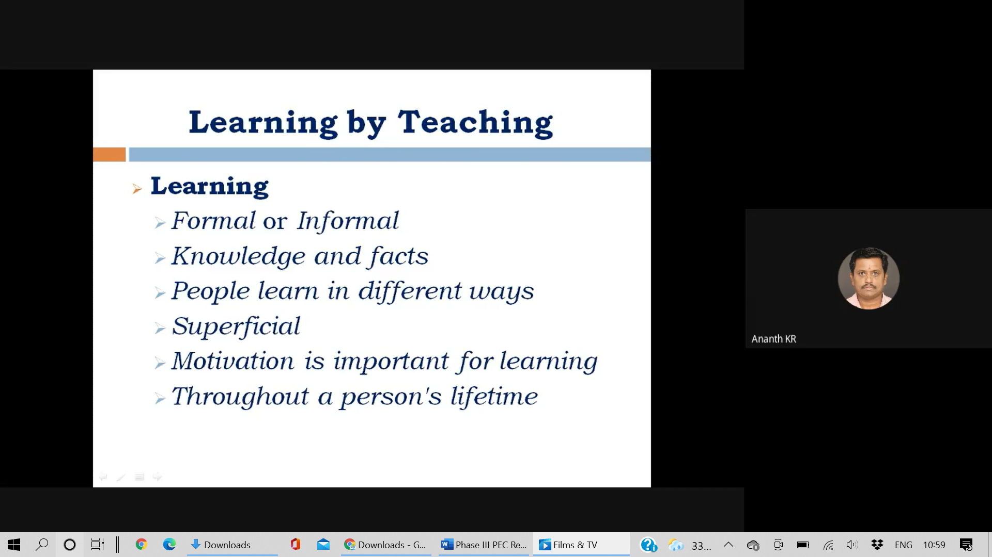

DAY: 3 - (08.04.2021)
Day3: Session 1: 10.00 AM to 11.30 AM
Session by Dr. S Viswanadha Raju, Professor & Vice Principal, JNTUH-CEJ
Topics Covered: Difference between Knowledge and Skills, Blooms Taxonomy
Bloom's Taxonomy of Educational Objectives can help with this. It's a way of understanding the different types of knowledge available, and the different levels of knowledge that we can achieve. What's more, it can guide us all to widen and deepen our learning. Knowledge is defined as the remembering of previously learned material. This may involve the recall of a wide range of material, from specific facts to complete theories, but all that is required is the bringing to mind of the appropriate information. Knowledge represents the lowest level of learning outcomes in the cognitive domain.

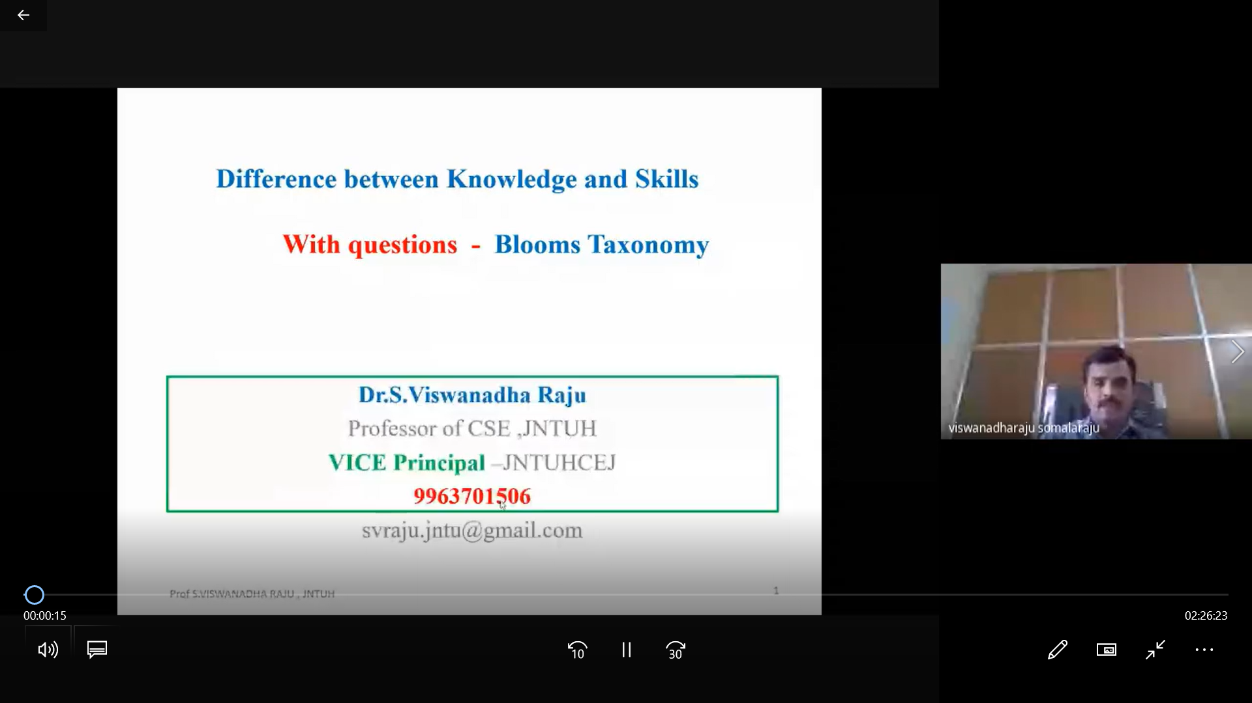
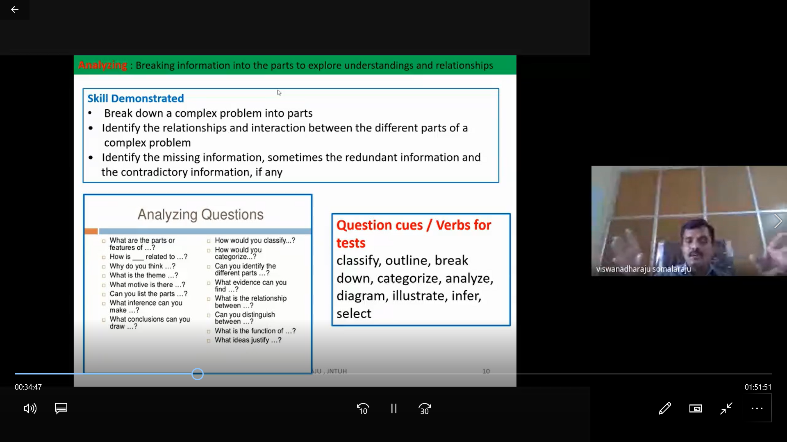

Day3: Session 2: 11.40 AM to 01.00 PM
Session by Dr. S. Jabeen Begum, Professor & HoD, CSE, VCET, TN
Topics Covered: Video Content Creation Tools
Video content is one of the most popular forms of content, some great tools to create videos, such as Wirecast, Videoshop, Magisto, Animoto, and Animaker etc., it has evolved to become much more than that. It is about finding the right audience for your business and connecting with them. It is about keeping them engaged with great content and innovative products and services.

Day3: Session 3: 2.00 PM to 3.30 PM
Session by Dr. K. Venugopal Rao, Professor, GNITS, Hyderabad
Topics Covered: Active Learning Strategies – A Pedagogical Perceptive & Innovative Methods of Teaching
Active learning refers to a broad range of teaching strategies which engage students as active participants in their learning during class time with their instructor. Typically, these strategies involve some amount of students working together during class, but may also involve individual work and/or reflection. These teaching approaches range from short, simple activities like journal writing, problem solving and paired discussions, to longer, involved activities or pedagogical frameworks like case studies, role plays, and structured team-based learning.

DAY: 4 - (09.04.2021)
Day4: Session 1: 10.00 AM to 11.30 AM
Session by Dr. S Viswanadha Raju, Professor & Vice Principal, JNTUH-CEJ
Topics Covered: Assessment Tools (OBE – Best Practices)
Outcomes-based Education Clearly focusing and organizing everything in an educational system around what is essential for all students to be able to do successfully at the end of their learning experiences.

Day4: Session 2: 11.40 AM to 01.00 PM
Session by K. Vijaya, Assistant Professor (Sr.Gr), CSE, VCET, TN
Topics Covered: Quantitative and Qualitative Measures in Education
Quantitative approaches are used to test and systematically measure the occurrence of a phenomenon, and qualitative methods are used to explore and deepen understanding of a phenomenon.
Day4: Session 3: 2.00 PM to 3.30 PM
Session by Dr. D. Prabakar, Asst. CoE, SNSCT, TN
Topics Covered: Advance Training Program on Teaching
Advance training program on teaching, the main objective is Strengthen skills and competencies in education policy analysis, sector diagnosis, plan formulation, and their implementation, monitoring, and evaluation, and Develop competencies in strategic management and leadership in education
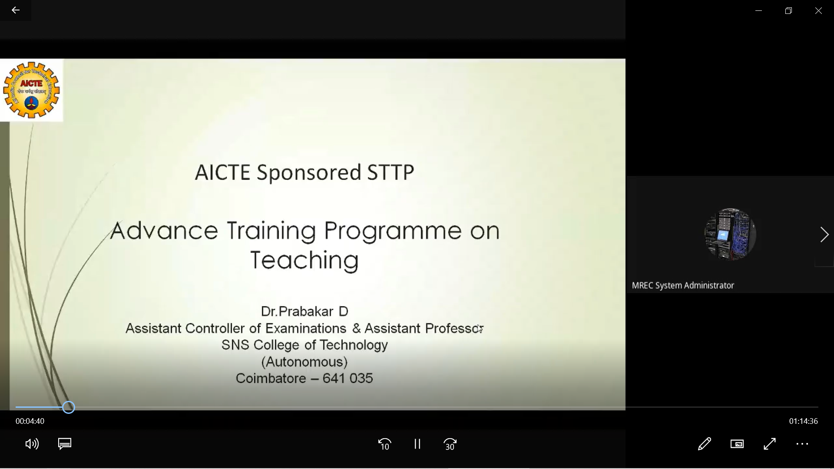
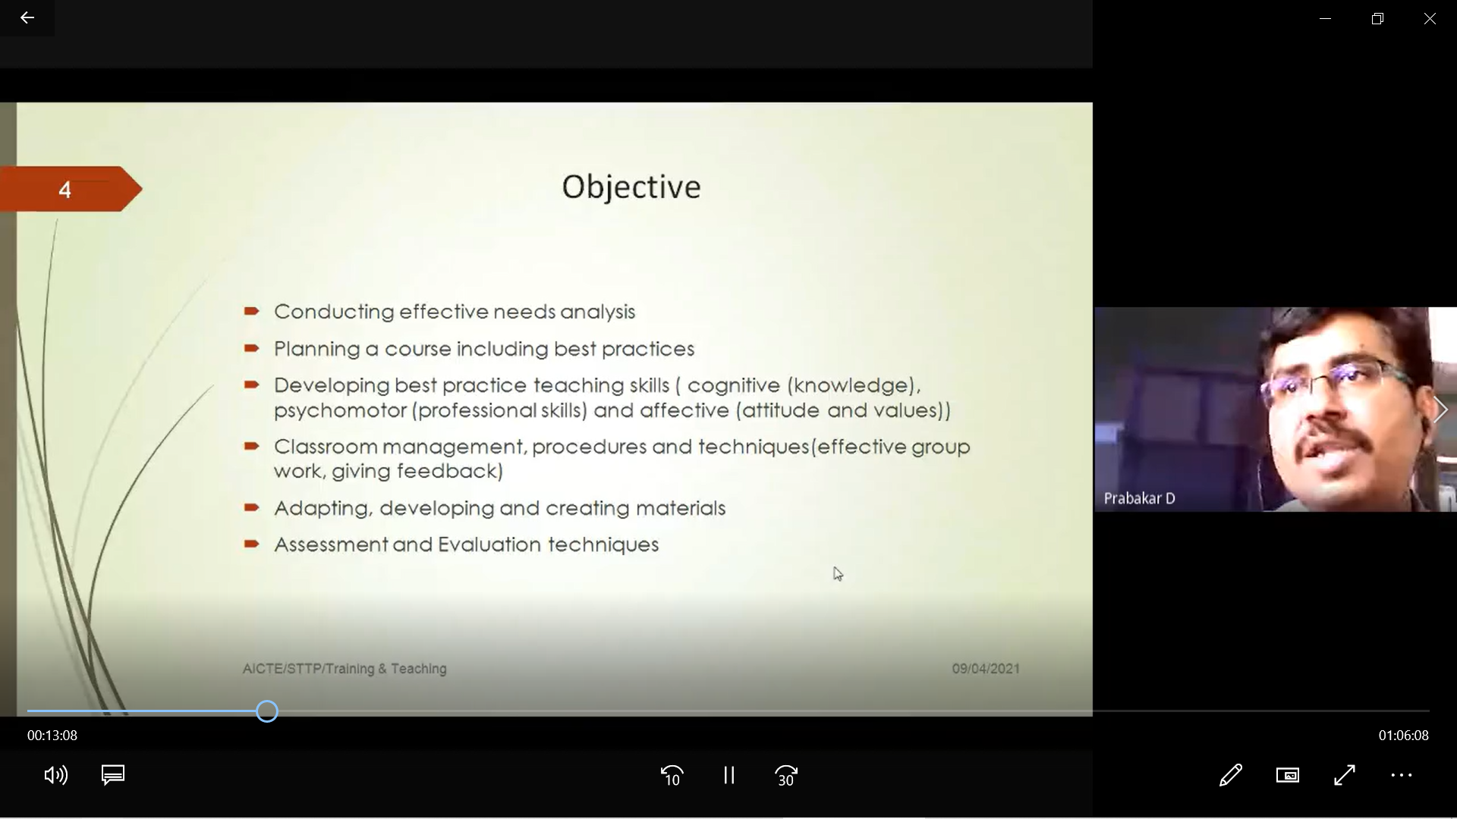

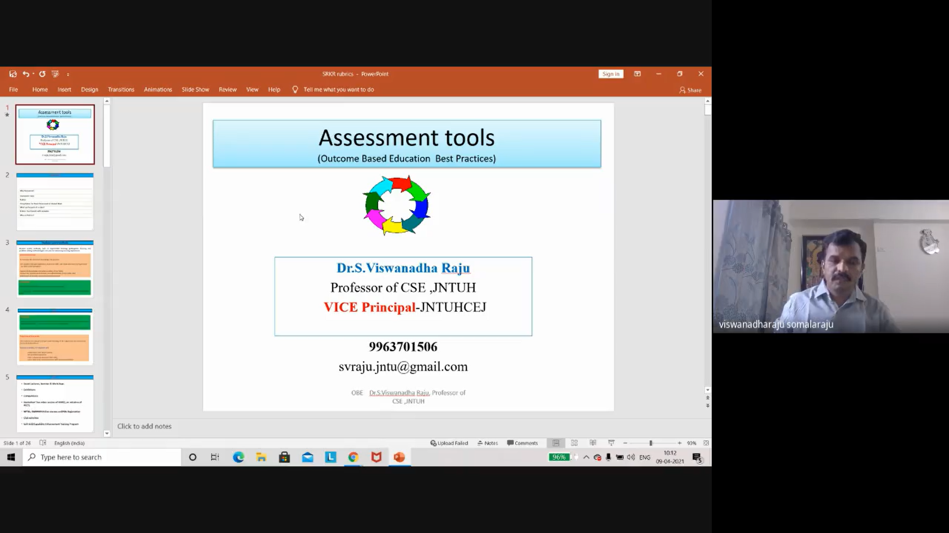
DAY: 5 - (10.04.2021)
Day5: Session 1: 10.00 AM to 11.30 AM
Session by Dr T V Rajini Kanth, Professor, SIST, Hyderabad.
Topics Covered: Motivating the Students to Work up to Full Potential for Success in Engineering Study
The best lessons, books, and materials in the world won’t get students excited about learning and some teaching classes can help students very fast to motivate. Student’s most important part is the motivation and once students has no fear or easily is motivated then it can be easily to succeed in their life. Teachers need to learn the tricks that work for motivating these socially and biologically flustered young minds.

Day5: Session 2: 11.40 AM to 01.00 PM
Session by Dr. R. P. Ram Kumar, Professor, CSE, MREC (A), Hyderabad
Topics Covered: Flipped Learning Objectives
The flipped classroom is a teaching approach where your students get their first exposure to course content before coming to class through readings and video lectures. They then spend in-class time engaging in activities that you’ve designed to promote a deeper understanding of a concept.

Day5: Session 3: 2.00 PM to 3.30 PM
Session by Dr. KV Subba Raju, Professor, SRKR Engg. College, TN
Topics Covered: Flipped Learning: An Effective Method for Classroom Management
In a flipped learning model of teaching, students get first contact with new ideas not during class time but in structured independent activities done prior to class time. This frees up class time to be used for more active work, digging more deeply into advanced ideas.

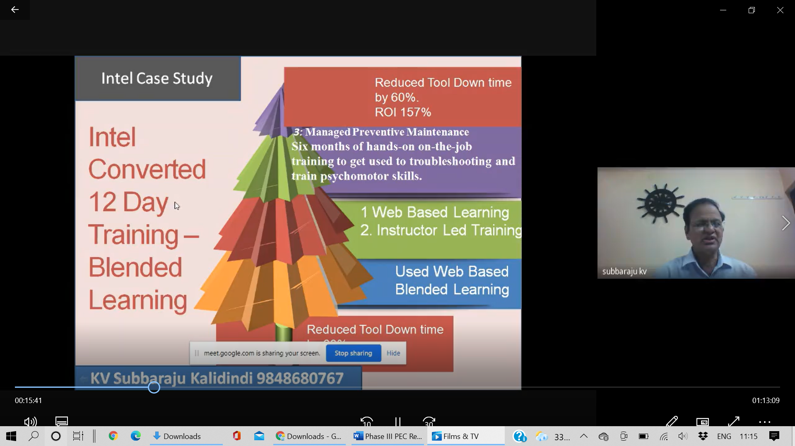

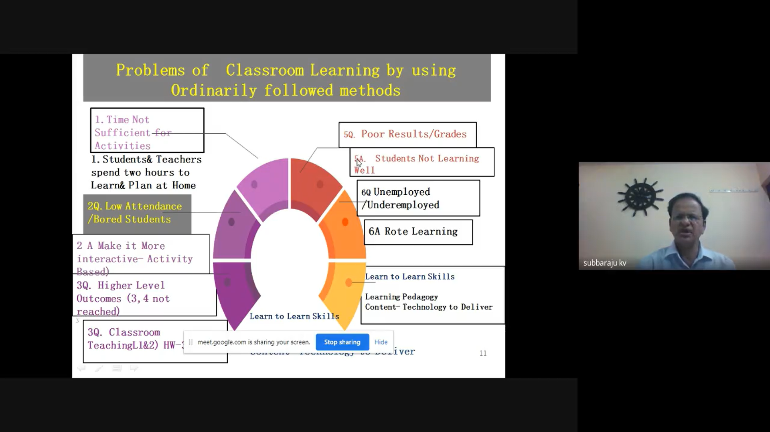

DAY: 6 - (12.04.2021)
Day6: Session 1: 10.00 AM to 11.30 AM
Session by Dr. T. Mohanapriya, Associate Professor, MBA, VCET, TN
Topics Covered: Teachers as Learners
Teachers are professional learners. Good teachers are able to incite students with a desire to learn. Effective teachers are able to stimulate students to learn specific types of things. You cannot teach somebody something. Teaching is guiding another person to opportunities for them to learn something.
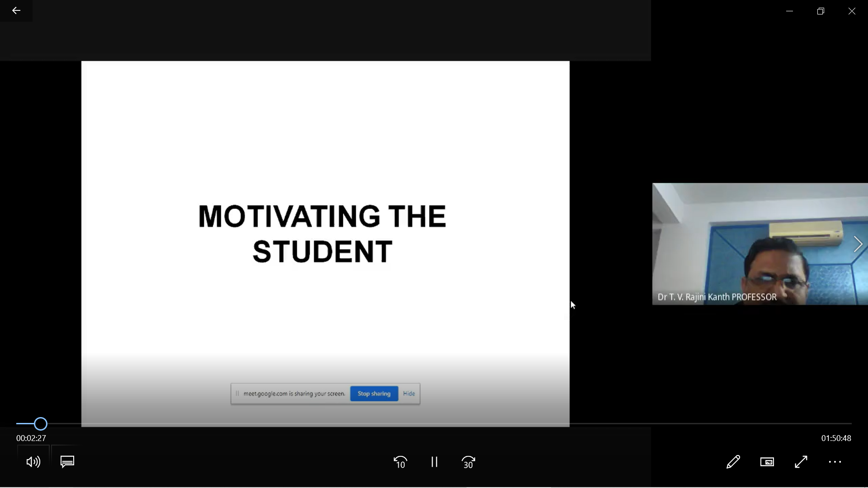

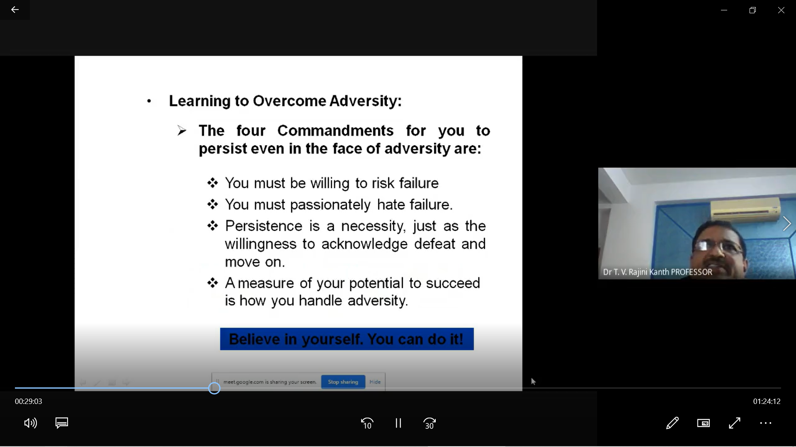
Day6: Session 2: 11.40 AM to 01.00 PM
Session by Dr. Deepa Jananakumar, Professor, VCET, TN
Topics Covered: Integrating Innovation and Teaching Strategies in the Traditional Classroom
Innovative teaching strategies which every teacher can embrace and make their teaching way more interesting, cross over teaching, teaching through smart boards, Teaching through Flipping Classrooms, Teaching through collaboration, Teaching through virtual reality and etc., For teachers, technology offers an endless set of resources that they can tap into depending on the need of the students.

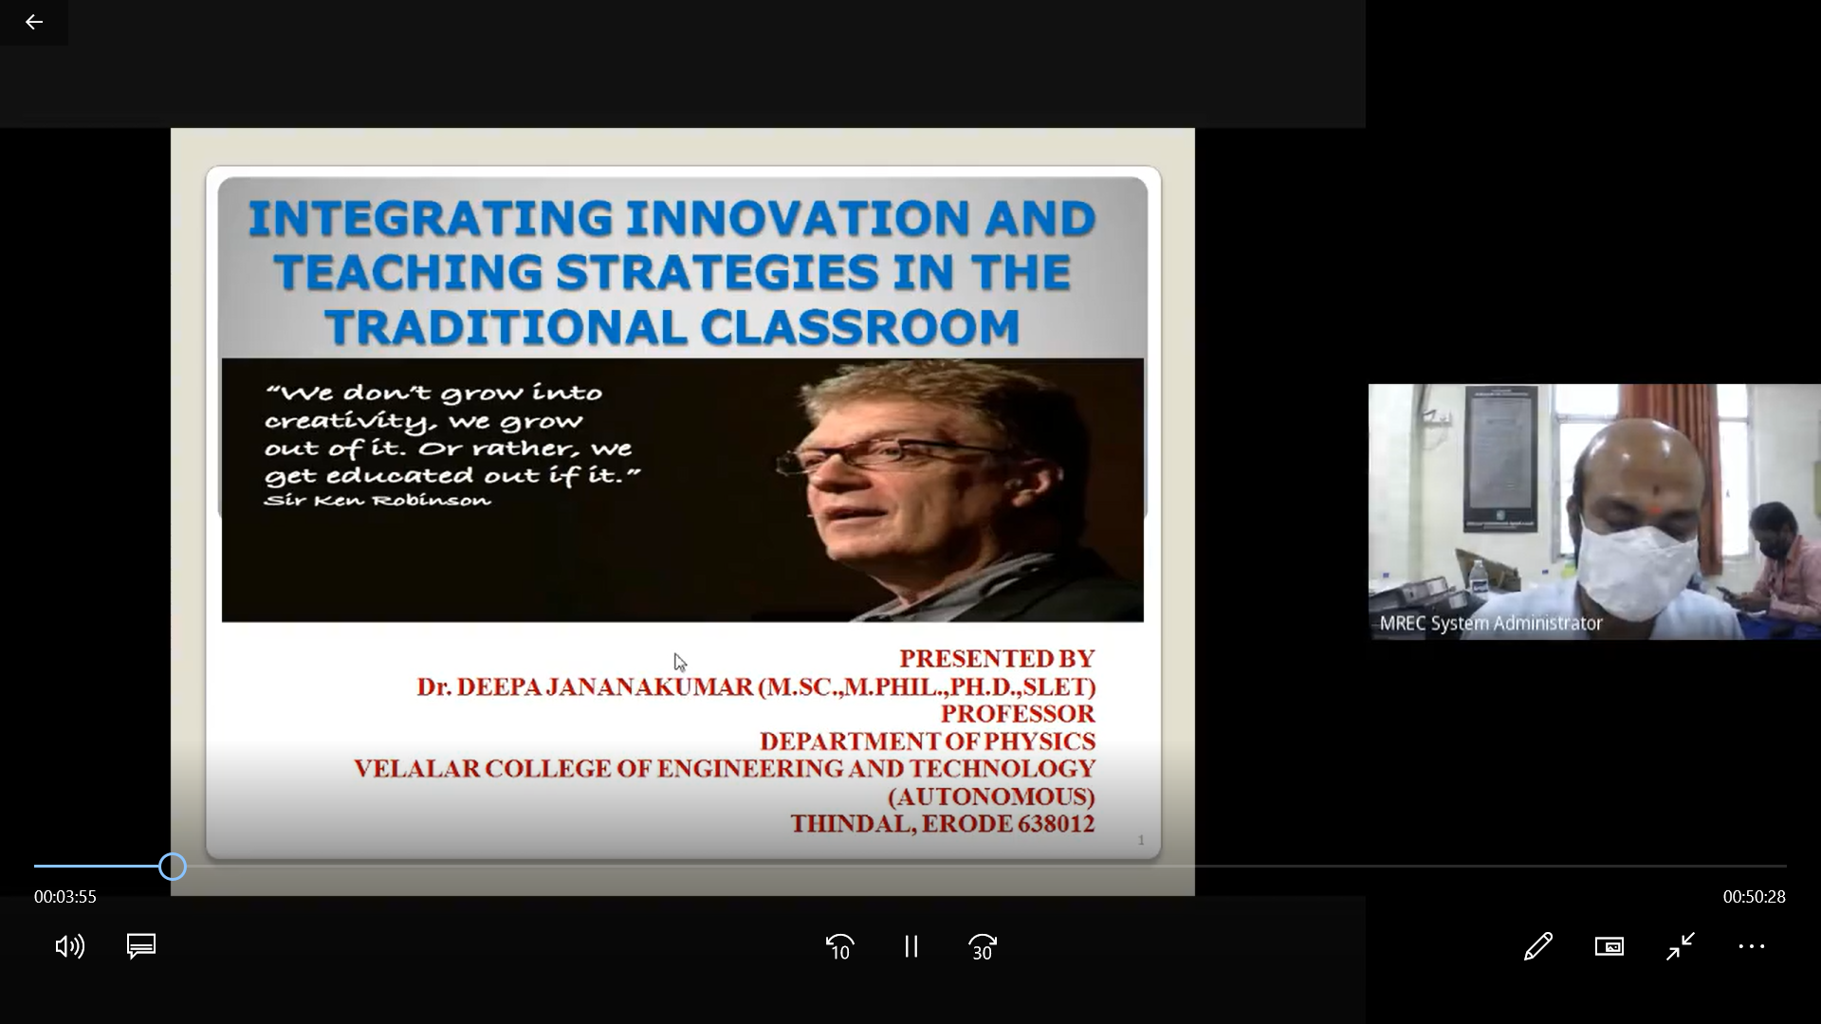
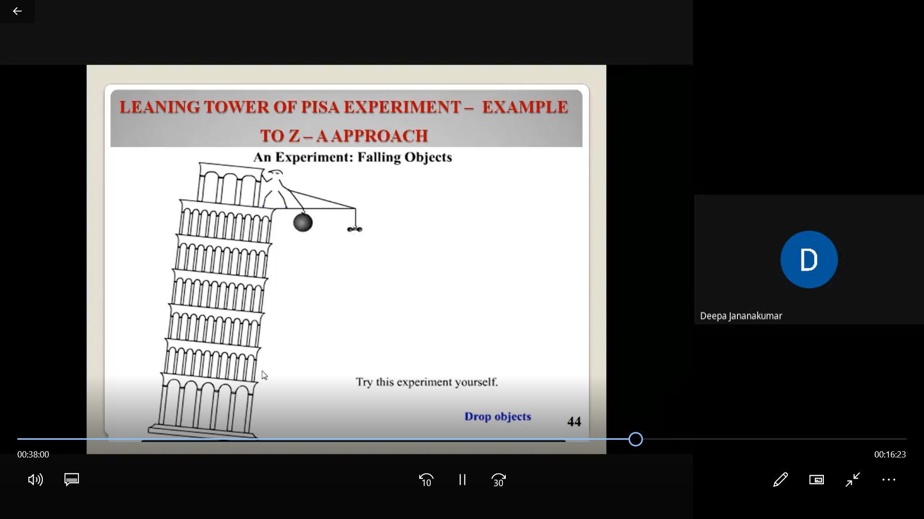

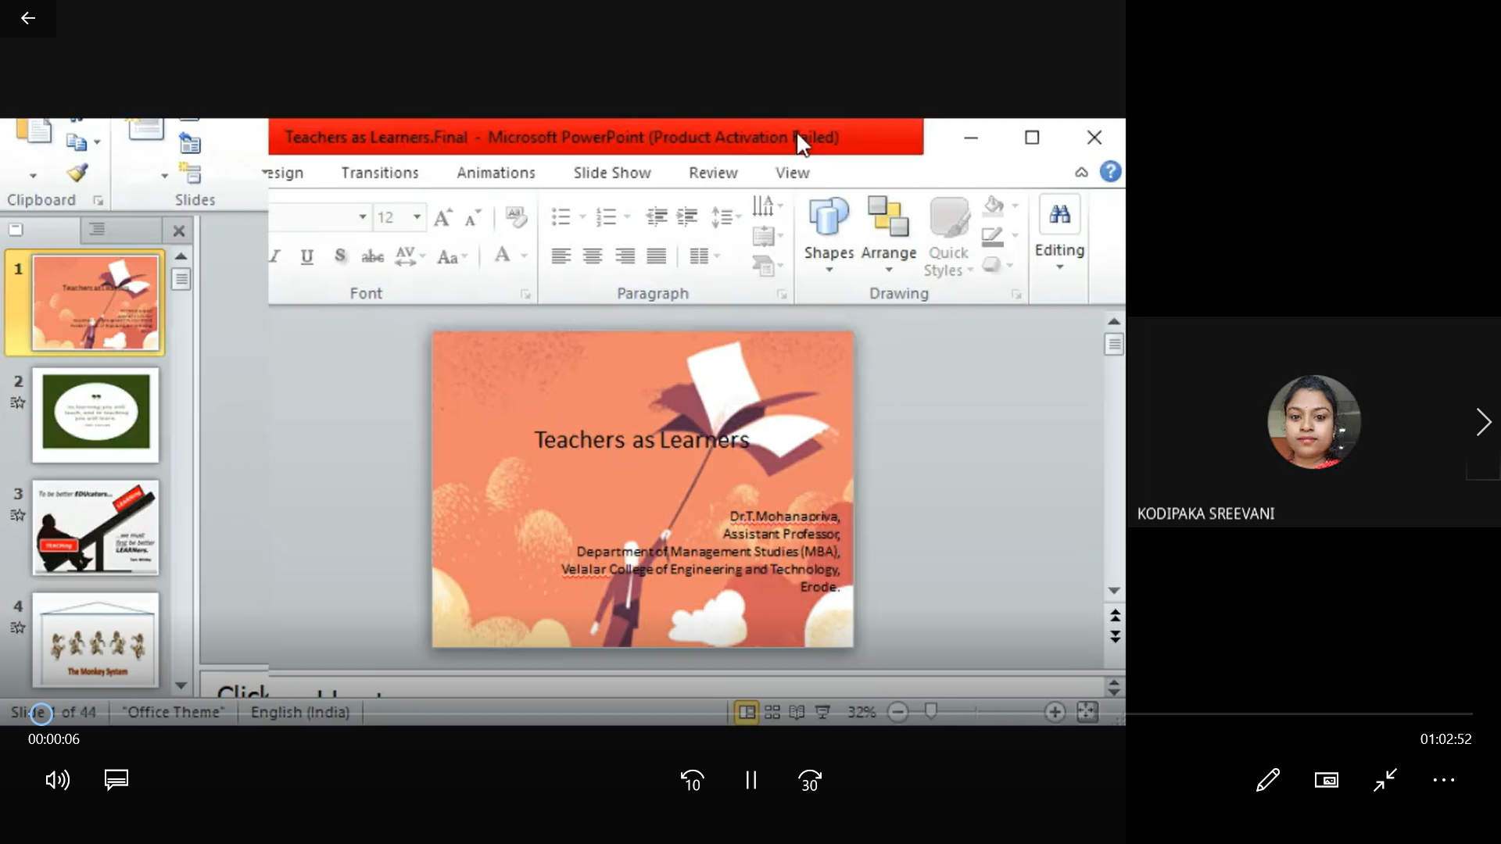
Day6: Session 3: 2.00 PM to 3.30 PM
Valedictory Function

On behalf of Malla Reddy Engineering College (Autonomous), Hyderabad, the Management, Secretary, Director sir, Principal sir and Coordinator of this program thanked all the participants participated in AICTE /ISTE Sponsored One Week (online) Induction / Refresher Program on “Advanced Training Program on Teaching” – Phase III.
A Special thanks to AICTE/ISTE for Sponsoring the Program
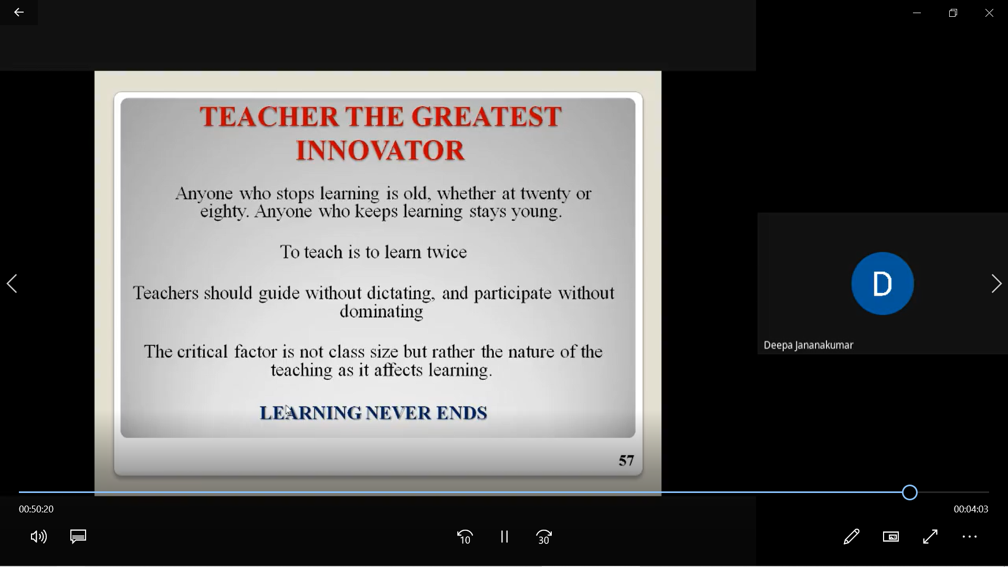

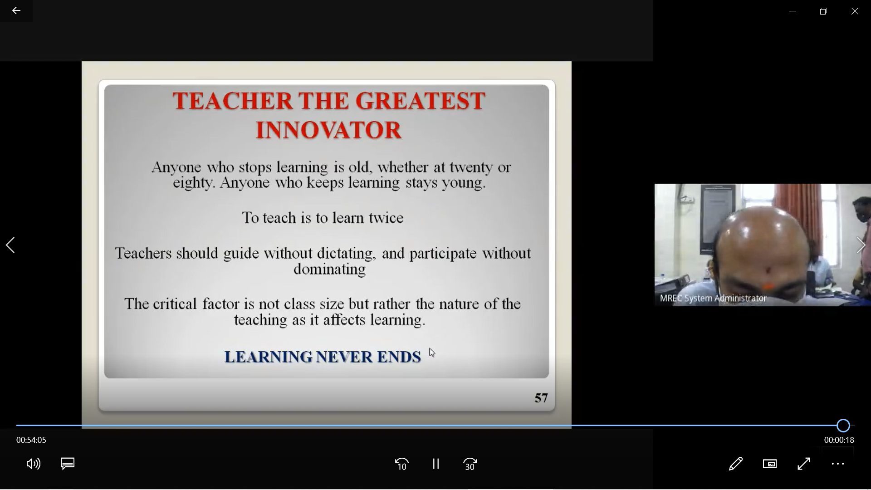

MALLA REDDY ENGINEERING COLLEGE (AUTONOMOUS)
MAISAMMAGUDA, DHULAPALLY (POST VIA KOMPALLY), SECUNDERABAD – 500100
DEPARTMENT OF COMPUTER SCIENCE AND ENGINEERING
AICTE – ISTE Sponsored One Week (Online)
INDUCTION / REFRESHER PROGRAM on
“Advanced Training Program on Teaching (Phase - III)”
6th – 12th April, 2021

Resource Persons Details
S.No | Date | Session | Name of the Resource Person | College Address
1 | 06.04.2021 | 11.40 to 1.00 | Dr. G Rajesh Kumar | Associate Professor,  CSE, VNRVJIET
 |  | 2.00 to 3.30 | Dr. More Swami Das | Professor, CSE, MREC(A)
2 | 07.04.2021 | 10.00 to 11.30 | Dr. K. R. Ananth | Professor, MCA, VCET, TN
 |  | 11.40 to 1.00 | Dr. S. Kayalvili | Professor, CSE, VCET, TN
 |  | 2.00 to 3.30 | Dr. Latha Jothi | Professor, CSE, VCET, TN
3 | 08.04.2021 | 10.00 to 11.30 | Dr. S Viswanadha Raju | Professor & Vice Principal, JNTUH-CEJ
 |  | 11.40 to 1.00 | Dr. S. Jabeen Begum | Professor & HoD, CSE,  VCET, TN
 |  | 2.00 to 3.30 | Dr. K. Venugopal Rao | Professor, GNITS
4 | 09.04.2021 | 10.00 to 11.30 | Dr. S Viswanadha Raju | Professor & Vice Principal, JNTUH-CEJ
 |  | 11.40 to 1.00 | K. Vijaya, | Assistant Professor (Sr.Gr)  CSE, VCET, TN
 |  | 2.00 to 3.30 | Dr. D. Prabakar, | Asst. CoE, SNSCT, TN
5 | 10.04.2021 | 10.00 to 11.30 | Dr T V Rajini Kanth | Professor, SIST, Hyderabad
 |  | 11.40 to 1.00 | Dr. R. P. Ram Kumar | Professor, CSE, MREC (A)
 |  | 2.00 to 3.30 | Dr. KV Subba Raju | Professor, SRKR Engg. College
6 | 11.04.2021 | 10.00 to 11.30 | Dr. T. Mohanapriya | Associate Professor,  MBA, VCET, TN
 |  | 11.40 to 1.00 | Dr. Deepa Jananakumar | Professor, VCET, TN

MALLA REDDY ENGINEERING COLLEGE (AUTONOMOUS)
MAISAMMAGUDA, DHULAPALLY (POST VIA KOMPALLY), SECUNDERABAD – 500100
DEPARTMENT OF COMPUTER SCIENCE AND ENGINEERING
AICTE – ISTE Sponsored One Week (Online)
INDUCTION / REFRESHER PROGRAM on
“Advanced Training Program on Teaching (Phase - I)”
6th – 12th April, 2021

List of Participants
S.No | Name of the Participant | Name of the College
1 | BANAVATHU RAJARAO | JNTUH, HYDERABAD
2 | Dr A S Nandane | A D Patel Institute of Technology
3 | Dr B Hari Krishna | Mallareddy Engineering College Autonomous
4 | Dr C Nageswaranath | BVRIT HYDERABAD College of Engineering for Women
5 | Dr M KOTI REDDY | Universal College of Engineering and Technology
6 | Dr M Vidhya | Govt Arts and Science College Kangeyam
7 | Dr. Abhimanyu Sethy | Icss college
8 | Dr. Aditi Chandel | Chitkara University
9 | Dr. Bhupinder Pal Singh Chahal | University School of Business, Chandigarh University
10 | Dr. Chandan B R | G Madegowda Institute of Technology
11 | Dr. G. RAJESH BABU | Nanjil Catholic college of arts and science, Kaliyakavilai
12 | Dr. Pattlola Srinivas | Malla Reddy Engineering College (A)
13 | Dr. Pokkuluri Kiran Sree | Shri Vishnu Engineering College for Women
14 | Dr. R. P. Ram Kumar | Malla Reddy Engineering College (Autonomous)
15 | Dr. Raghunadh Pasunuri | MREC AUTONOMOUS Hyderabad
16 | Dr. Rhytheema Dulloo | Hindustan Institute Of Technology And Science
17 | Dr. S. JOTHILAKSHMI | Government Arts and Science College, Kangeyam
18 | Dr. S. Vijayaragavan | Muthayammal engineering college
19 | Dr.C.Thanavathi | V.O.C.College of Education
20 | Dr.Chitra A.Dhawale | P.R.Pote College of Engineering and Management
21 | Dr.G.VENKATESAN | Sona College of Arts and Science
22 | Dr.Gurumeet wadhawa | Karmaveer bhaurao patil college vashi
23 | Dr.k.kavita | Bvrithyderabad College of engineering for women
24 | Dr.Meenakshi Rathi | Govt Adarsh College Harda M.P
25 | Dr.Murugesan Senthil | Swarna Bharathi Institute of Science and Technology
26 | Dr.S.Dhanalakshmi | Malla Reddy Engineering College Autonomous
27 | Dr.S.SIVANESHWARAN | Sri Krishna arts and science college coimbatore
28 | G JAGAN NAIK | MREC(A)
29 | I KAPIL KUMAR | Tamilnadu Teachers Education University
30 | K.Sindhuja | Mallareddy engineering college
31 | K.SUBBA SHANKAR | MREC (Autonomous) _ Main Campus
32 | K.Swaminathan | Perunthalaivar kamarajar Institute of engineering and technology
33 | Kamaljeet singh | GNA university
34 | Ketan Sarvakar | Ganpat University
35 | Mangalagiri Pallavi | Vignan Institute of Engineering for women
36 | Mr G Jagan Naik | Malla Reddy Engineering College (Autonomous)
37 | Mr V Lingamaiah | Malla Reddy Engineering College (Autonomous)
38 | Mr. Aarepu Lakshman | Malla Reddy Engineering College (Autonomous)
39 | Mr. Chinmaya Dash | St. Claret College
40 | Mr. E. Sunil | Malla Reddy Engineering College (Autonomous)
41 | Mr. J.S.S.K.Vasa | Malla Reddy Engineering College (Autonomous)
42 | Mr. Narinder Kumar | GNA University Phagwara
43 | Mr. P. SENTHIL | Malla Reddy Engineering College (Autonomous)
44 | Mr. Pasam Venkateshwar Rao | Malla Reddy Engineering College (Autonomous)
45 | Mr. S Ajay Kumar | Malla Reddy Engineering College Autonomous
46 | Mr. Sanjeeva Polepaka | Malla Reddy Engineering College (Autonomous)
47 | Mr. Sohang Debnath | Malla Reddy Engineering College (Autonomous)
48 | Mr.Akoju Ramu | Malla Reddy Engineering College (Autonomous)
49 | Mr.T.ARUL RAJ | MANONMANIAM SUNDARANAR UNIVERSITY
50 | Mrs B Saritha | Malla Reddy Engineering College (Autonomous)
51 | Mrs. Chandrakala. M | Kristu Jayanti College Bangalore
52 | Mrs. Nomula divya | Mrec(autonomous)
53 | Mrs. Pragada Akhila | GVPCOE (A)
54 | Mrs.Apurva Khandekar | Malla Reddy Engineering College (Autonomous)
55 | Ms. Amrutha Yellanki | Malla Reddy Engineering College (Autonomous)
56 | Ms. Damarla Haritha | Maturi Venkata Subba Rao Engineering College
57 | Ms. K.PARVATHAVARTHINE | MANONMANIAM SUNDARANAR UNIVERSITY
58 | MS. Palla Sravani | Vignan's Institute of Engineering for Women
59 | Ms. S. KARTHIKEYENI | KONGU ARTS AND SCIENCE COLLEGE(AUTONOMOUS)
60 | Ms. S.Grace Manasa | Malla Reddy Engineering College (Autonomous)
61 | Ms.A Jhoncy | Bharath Institute of Higher Education and Research
62 | Ms.Kesireddy Radhika | Malla Reddy Engineering College (Autonomous)
63 | Ms.M.ELLAKKIYA | Cauvery college for women Autonomous
64 | Nikunj S. Yagnik | A D Patel Institute of Technology
65 | Parllela Shanthan kumar | IARE
66 | Polumati suvarna pushpa | Mallareddy engineering college
67 | PRASHANTH MIRYALA | MALLA REDDY ENGINEERING COLLEGE (AUTONOMOUS)
68 | Prof. Ch GVN Prasad | Malla Reddy Engineering College
69 | R KUPPUCHAMY | PSNA COLLEGE OF ENGINEERING AND TECHNOLOGY
70 | SRIKANTH PARIKIBANDLA | GITAM DEEMED TO BE UNIVERSITY, VISAKHAPATNAM
71 | SSSN USHA DEVI N | University College of Engineering, JNTU KAKINADA
72 | V BALARAJU | SVU College of Engineering Tirupati
73 | V.PADMINI | Government Arts and Science College, Kangeyam

MALLA REDDY ENGINEERING COLLEGE (AUTONOMOUS)
MAISAMMAGUDA, DHULAPALLY (POST VIA KOMPALLY), SECUNDERABAD – 500100
DEPARTMENT OF COMPUTER SCIENCE AND ENGINEERING
AICTE – ISTE Sponsored One Week (Online)
INDUCTION / REFRESHER PROGRAM on
“Advanced Training Program on Teaching (Phase - III)”
6th – 12th April, 2021

Question Paper

1) ___________or “hybrid learning” represents a learning model that combines both formal (traditional classroom) and non-formal (online courses) methodologies. [ ]
a) blended learning b) online learning
c) demonstration d) None

2) ________is an approach to education that combines online educational materials and opportunities for interaction online with traditional place-based classroom methods. It requires the physical presence of both teacher and student, with some elements of student control over time, place, path, or pace. [ ]
a) Blended learning b) online learning
c) demonstration d) None

3) Which of the following statements about classroom management is TRUE? [ ]
a) There is a 'one size fits all' template that everyone must use.
b) Your systems and procedures should always be age-appropriate.
c)It is the same as behavior management.
d)You can get along fine without a classroom management plan.

4) Which of the following is the BEST definition of instructional procedures? [ ]
a) Lesson plans to help you teach students how to complete certain tasks and activities in your classroom.
b) Procedures created, planned, and implemented to keep things running efficiently in the classroom.
c) Rules and regulations that the teacher creates for how students should behave at recess.
d) Guides in the curriculum for teaching students how to keep things running smoothly in the classroom.

5) Why should teachers ensure there are physical pathways for students? [ ]
a) It makes it easier to attend to individual students' needs.
b) It makes students less likely to become distracted.
c) It makes it easier for students to see the blackboard.
d) It helps allows the students private space to work by themselves.

6) How can teachers create a warm, welcoming learning space? [ ]
a) By supplying the room with colorful learning aids
b) By personalizing the classroom with accessories
c) By focusing on keeping the classroom quiet
d) By teaching students to keep their work spaces tidy

7) Which of the following best describes rapport as it relates to education? [ ]
a) Teachers who are liked by the students
b) Teachers who are entertaining to students
c) Teachers who demonstrate strong relationships with students
d) Teachers who teach with a sense of humor

8) Which of the following factors is likely to have a a negative impact on classroom experience?
a) Students' age determines the type of tasks they are assigned [ ]
b) There are breaks between tasks
c) Time spent on each task is planned ahead by the teacher
d) There is plenty of seat work to prevent students from being bored

9) How should you implement strategies to establish classroom norms and expectations?
a) By modifying them depending on your needs that day. [ ]
b) By carrying them out exactly as they are stated.
c) None of the answers are correct.
d) By modifying them to fit the grade and age level of your students.

10) Which of the following information is appropriate for students to share with others online?
a) Their address b) Their interests [ ]
c) Their full name d) Their college name

11) Creating rewards and consequences in the classroom: [ ] a) Focuses on recognizing positive behavior over negative behavior.
b) Gives well-behaved students more control in the classroom.
c) Tends to produce robot-like students who only perform on command.
d) Should only be used when the students' behavior requires managing.

12) Which of the following learner characteristic is highly related of effectiveness of teaching.
a) Prior experience of the learner [ ]
b) Educational status of the parents of the learner
c) Peer groups of the learner
d) Family size from which the learners come

13) On the basic of summative tests, a teacher is interpreting his/her students’ performance in terms of their wellness lifestyle evident in behavior. This will be called______ [ ]
a) Formative testing
b) Continuous and comprehensive evaluation
c) Norm referenced testing
d) Criterion referenced testing

14) Which one of the following is a key behavior in effective teaching? [ ]
a) Using student ideas and contribution
b) Structuring
c) Instructional variety
d) Questioning

15) Effective of teaching has to be judged in terms of [ ]
a) Course coverage
b) Student interest
c) Learning outcome
d) Use of Teaching.

16) In which teaching method learners participation is made optimal and proactive? [ ]
a) Discussion method
b) Buzz session method
c) Brainstorming session method
d) Project method

17) One of the most powerful factors affecting teaching effectiveness is related to the [ ]
a) Social system of the country
b) Economic status of the society
c) Prevailing political system
d) Educational system

18) As a Teacher select the best option to ensure your effective presence in the classroom
a) Use of peer command [ ]
b) Making aggressive statements
c) Adoption of well-established posture
d) Being authoritarian

19) At the knowledge level students will _______ [ ]
a) Argue the point
b) Recall information
c) Categorize topics
d) Calculate distances

20) Which type of question is a sample of Evaluation? [ ]
a) Do you agree with the actions of Sam?
b) Why was it better than
c) What sources can you use to support your opinion?
d) All of the above

21) What can you invent or design is a sample of? [ ]
a) Knowledge
b) Comprehension
c) Application
d) Synthesis

22) What ways could you change the plot of the story? Is this question _______ [ ]
a) Synthesis
b) Comprehension
c) Knowledge
d) Application

23) Defend the actions of the main character. What level of Bloom's Taxonomy is this?
a) Evaluation [ ]
b) Comprehension
c) Analysis
d) None of the above

24) Infer, follow, interpret, summarize, demonstrate, cite and interpolate are all verbs representing what level of Bloom's taxonomy [ ]
a) Application
b) Knowledge
c) Synthesis
d) Comprehension

25) The teacher studies pupils group behavior mainly by which of the following methods?
a) Interview [ ]
b) Experimentation
c) Case history
d) Observation

26) Which is not a factor of motivation? [ ]
a) Prize
b) Incentive
c) Praise
d) Practice

27) Which one does not indicate child’s / students emotion? [ ]
a) Pleasure
b) Sorrow
c) Curiosity
d) Tolerance

28) Which one of the following is not an element of mastery learning? [ ]
a) Use of alternate text-book
b) Alternate methods of teaching
c) Child/Student-centered learning activity
d) Group

29) Which one of the following is measured by continuous comprehensive evaluation?
a) Holistic development [ ]
b) Development of creativity
c) Development of experience
d) Development of divergent thinking

30) Which of the following is a dimensional teaching aid? [ ]
a) Black Board
b) Display Board
c) Still Picture
d) Model

MALLA REDDY ENGINEERING COLLEGE (AUTONOMOUS)
MAISAMMAGUDA, DHULAPALLY (POST VIA KOMPALLY), SECUNDERABAD – 500100
DEPARTMENT OF COMPUTER SCIENCE AND ENGINEERING
AICTE – ISTE Sponsored One Week (Online)
INDUCTION / REFRESHER PROGRAM on
“Advanced Training Program on Teaching (Phase - III)”
6th – 12th April, 2021

Answers
Q. No | Answer |  | Q. No | Answer
1 | A |  | 16 | A
2 | A |  | 17 | D
3 | B |  | 18 | C
4 | B |  | 19 | B
5 | A |  | 20 | D
6 | B |  | 21 | D
7 | C |  | 22 | A
8 | C |  | 23 | C
9 | D |  | 24 | D
10 | B |  | 25 | D
11 | A |  | 26 | D
12 | A |  | 27 | D
13 | D |  | 28 | D
14 | C |  | 29 | A
15 | C |  | 30 | D

MALLA REDDY ENGINEERING COLLEGE (AUTONOMOUS)
MAISAMMAGUDA, DHULAPALLY (POST VIA KOMPALLY), SECUNDERABAD – 500100
DEPARTMENT OF COMPUTER SCIENCE AND ENGINEERING
AICTE – ISTE Sponsored One Week (Online)
INDUCTION / REFRESHER PROGRAM on
“Advanced Training Program on Teaching (Phase - III)”
6th – 12th April, 2021

LIST OF QUALIFIED PARTICIPANTS

S.No | Name of the Participant | Name of the College
1 | BANAVATHU RAJARAO | JNTUH, HYDERABAD
2 | Dr A S Nandane | A D Patel Institute of Technology
3 | Dr B Hari Krishna | Mallareddy Engineering College Autonomous
4 | Dr C Nageswaranath | BVRIT HYDERABAD College of Engineering for Women
5 | Dr M KOTI REDDY | Universal College of Engineering and Technology
6 | Dr M Vidhya | Govt Arts and Science College Kangeyam
7 | Dr. Abhimanyu Sethy | Icss college
8 | Dr. Aditi Chandel | Chitkara University
9 | Dr. Bhupinder Pal Singh Chahal | University School of Business, Chandigarh University
10 | Dr. Chandan B R | G Madegowda Institute of Technology
11 | Dr. G. RAJESH BABU | Nanjil Catholic college of arts and science, Kaliyakavilai
12 | Dr. Pattlola Srinivas | Malla Reddy Engineering College (A)
13 | Dr. Pokkuluri Kiran Sree | Shri Vishnu Engineering College for Women
14 | Dr. R. P. Ram Kumar | Malla Reddy Engineering College (Autonomous)
15 | Dr. Raghunadh Pasunuri | MREC AUTONOMOUS Hyderabad
16 | Dr. Rhytheema Dulloo | Hindustan Institute Of Technology And Science
17 | Dr. S. JOTHILAKSHMI | Government Arts and Science College, Kangeyam
18 | Dr. S. Vijayaragavan | Muthayammal engineering college
19 | Dr.C.Thanavathi | V.O.C.College of Education
20 | Dr.Chitra A.Dhawale | P.R.Pote College of Engineering and Management
21 | Dr.G.VENKATESAN | Sona College of Arts and Science
22 | Dr.Gurumeet wadhawa | Karmaveer bhaurao patil college vashi
23 | Dr.k.kavita | Bvrithyderabad College of engineering for women
24 | Dr.Meenakshi Rathi | Govt Adarsh College Harda M.P
25 | Dr.Murugesan Senthil | Swarna Bharathi Institute of Science and Technology
26 | Dr.S.Dhanalakshmi | Malla Reddy Engineering College Autonomous
27 | Dr.S.SIVANESHWARAN | Sri Krishna arts and science college coimbatore
28 | G JAGAN NAIK | MREC(A)
29 | I KAPIL KUMAR | Tamilnadu Teachers Education University
30 | K.Sindhuja | Mallareddy engineering college
31 | K.SUBBA SHANKAR | MREC (Autonomous) _ Main Campus
32 | K.Swaminathan | Perunthalaivar kamarajar Institute of engineering and technology
33 | Kamaljeet singh | GNA university
34 | Ketan Sarvakar | Ganpat University
35 | Mangalagiri Pallavi | Vignan Institute of Engineering for women
36 | Mr G Jagan Naik | Malla Reddy Engineering College (Autonomous)
37 | Mr V Lingamaiah | Malla Reddy Engineering College (Autonomous)
38 | Mr. Aarepu Lakshman | Malla Reddy Engineering College (Autonomous)
39 | Mr. Chinmaya Dash | St. Claret College
40 | Mr. E. Sunil | Malla Reddy Engineering College (Autonomous)
41 | Mr. J.S.S.K.Vasa | Malla Reddy Engineering College (Autonomous)
42 | Mr. Narinder Kumar | GNA University Phagwara
43 | Mr. P. SENTHIL | Malla Reddy Engineering College (Autonomous)
44 | Mr. Pasam Venkateshwar Rao | Malla Reddy Engineering College (Autonomous)
45 | Mr. S Ajay Kumar | Malla Reddy Engineering College Autonomous
46 | Mr. Sanjeeva Polepaka | Malla Reddy Engineering College (Autonomous)
47 | Mr. Sohang Debnath | Malla Reddy Engineering College (Autonomous)
48 | Mr.Akoju Ramu | Malla Reddy Engineering College (Autonomous)
49 | Mr.T.ARUL RAJ | MANONMANIAM SUNDARANAR UNIVERSITY
50 | Mrs B Saritha | Malla Reddy Engineering College (Autonomous)
51 | Mrs. Chandrakala. M | Kristu Jayanti College Bangalore
52 | Mrs. Nomula divya | Mrec(autonomous)
53 | Mrs. Pragada Akhila | GVPCOE (A)
54 | Mrs.Apurva Khandekar | Malla Reddy Engineering College (Autonomous)
55 | Ms. Amrutha Yellanki | Malla Reddy Engineering College (Autonomous)
56 | Ms. Damarla Haritha | Maturi Venkata Subba Rao Engineering College
57 | Ms. K.PARVATHAVARTHINE | MANONMANIAM SUNDARANAR UNIVERSITY
58 | MS. Palla Sravani | Vignan's Institute of Engineering for Women
59 | Ms. S. KARTHIKEYENI | KONGU ARTS AND SCIENCE COLLEGE(AUTONOMOUS)
60 | Ms. S.Grace Manasa | Malla Reddy Engineering College (Autonomous)
61 | Ms.A Jhoncy | Bharath Institute of Higher Education and Research
62 | Ms.Kesireddy Radhika | Malla Reddy Engineering College (Autonomous)
63 | Ms.M.ELLAKKIYA | Cauvery college for women Autonomous
64 | Nikunj S. Yagnik | A D Patel Institute of Technology
65 | Parllela Shanthan kumar | IARE
66 | Polumati suvarna pushpa | Mallareddy engineering college
67 | PRASHANTH MIRYALA | MALLA REDDY ENGINEERING COLLEGE (AUTONOMOUS)
68 | Prof. Ch GVN Prasad | Malla Reddy Engineering College
69 | R KUPPUCHAMY | PSNA COLLEGE OF ENGINEERING AND TECHNOLOGY
70 | SRIKANTH PARIKIBANDLA | GITAM DEEMED TO BE UNIVERSITY, VISAKHAPATNAM
71 | SSSN USHA DEVI N | University College of Engineering, JNTU KAKINADA
72 | V BALARAJU | SVU College of Engineering Tirupati
73 | V.PADMINI | Government Arts and Science College, Kangeyam
MALLA REDDY ENGINEERING COLLEGE (AUTONOMOUS)
MAISAMMAGUDA, DHULAPALLY (POST VIA KOMPALLY), SECUNDERABAD – 500100
DEPARTMENT OF COMPUTER SCIENCE AND ENGINEERING
AICTE – ISTE Sponsored One Week (Online)
INDUCTION / REFRESHER PROGRAM on
“Advanced Training Program on Teaching (Phase - III)”
6th – 12th April, 2021

PROGRAM EVALUATION COMMITTEE

_______________________________  Dr. G. CHARLES BABU  (Member Secretary) | _____________________________  Dr. R. P. RAM KUMAR  (Member)
_____________________________  Dr. S. MADHU BABU  (Member) | _____________________________  Dr. N LAKSHMIPATHI ANANTHA  (Member)
_____________________________
Dr. A. RAVEENDRA
(Chairperson)

MALLA REDDY ENGINEERING COLLEGE (AUTONOMOUS)
MAISAMMAGUDA, DHULAPALLY (POST VIA KOMPALLY), SECUNDERABAD – 500100
DEPARTMENT OF COMPUTER SCIENCE AND ENGINEERING
AICTE – ISTE Sponsored One Week (Online)
INDUCTION / REFRESHER PROGRAM on
“Advanced Training Program on Teaching (Phase - III)”
6th – 12th April, 2021

Report on Inaugural Function
The AICTE – ISTE Sponsored One Week (Online) INDUCTION / REFRESHER PROGRAM on “Advanced Training Program on Teaching (Phase - I)” organized by Department of Computer Science and Engineering, Malla Reddy Engineering College (Autonomous) – Main Campus, scheduled from 09th – 15th February is inaugurated by Dr. S.Viswanadha Raju, Professor in CSE & Vice Principal, JNTUH CEJ.
Dr. A. Ramaswami Reddy, Director, MREC (A), addressed the INDUCTION / REFRESHER PROGRAM participants from various part of the country. Followed by the inaugural session, Dr. S.Viswanadha Raju, Professor in CSE & Vice Principal, JNTUH CEJ Chief Guest, addressed the participants. Finally, Dr. G. Charles Babu, Professor in CSE & Coordinator of the Program, Welcome the Participants.

MALLA REDDY ENGINEERING COLLEGE (AUTONOMOUS)
MAISAMMAGUDA, DHULAPALLY (POST VIA KOMPALLY), SECUNDERABAD – 500100
DEPARTMENT OF COMPUTER SCIENCE AND ENGINEERING
AICTE – ISTE Sponsored One Week (Online)
INDUCTION / REFRESHER PROGRAM on
“Advanced Training Program on Teaching (Phase - III)”
6th – 12th April, 2021

Outcome of the FDP
INDUCTION / REFRESHER PROGRAM on “Advanced Training Program on Teaching (Phase - I)” The entire programme is coordinated by Dr. G. Charles Babu and Dr. M.Swami Das of CSE Department.

Dr. G. CHARLES BABU  (Member Secretary) | Dr. R. P. RAM KUMAR  (Member)
Dr. S. MADHU BABU  (Member) | Dr. N LAKSHMIPATHI ANANTHA  (Member)
Dr. A. RAVEENDRA
(Chairperson)

MALLA REDDY ENGINEERING COLLEGE (AUTONOMOUS)
MAISAMMAGUDA, DHULAPALLY (POST VIA KOMPALLY), SECUNDERABAD – 500100
DEPARTMENT OF COMPUTER SCIENCE AND ENGINEERING
AICTE – ISTE Sponsored One Week (Online)
INDUCTION / REFRESHER PROGRAM on
“Advanced Training Program on Teaching (Phase - III)”
6th – 12th April, 2021

Participants Feedback
Day-1
S. No | Name of the Participant | Name of the College/ University | Session Date | Feedback about the session
1 | BANAVATHU RAJARAO | JNTUH, HYDERABAD | 06.04.2021 | Excellent
2 | Dr A S NANDANE | A D Patel Institute of Technology | 06.04.2021 | Excellent
3 | DR B HARI KRISHNA | MALLAREDDY ENGINEERING COLLEGE AUTONOMOUS | 06.04.2021 | EXCELLENT
4 | DR C NAGESWARANATH | BVRIT HYDERABAD COLLEGE OF ENGINEERING FOR WOMEN | 06.04.2021 | EXCELLENT
5 | DR M KOTI REDDY | UNIVERSAL COLLEGE OF ENGINEERING AND TECHNOLOGY | 06.04.2021 | VERY GOOD
6 | DR M VIDHYA | GOVT ARTS AND SCIENCE COLLEGE KANGEYAM | 06.04.2021 | VERY GOOD
7 | DR. ABHIMANYU SETHY | ICSS COLLEGE | 06.04.2021 | EXCELLENT
8 | DR. ADITI CHANDEL | CHITKARA UNIVERSITY | 06.04.2021 | EXCELLENT
9 | DR. BHUPINDER PAL SINGH CHAHAL | UNIVERSITY SCHOOL OF BUSINESS, CHANDIGARH UNIVERSITY | 06.04.2021 | VERY GOOD
10 | DR. CHANDAN B R | G MADEGOWDA INSTITUTE OF TECHNOLOGY | 06.04.2021 | EXCELLENT
11 | DR. G. RAJESH BABU | NANJIL CATHOLIC COLLEGE OF ARTS AND SCIENCE, KALIYAKAVILAI | 06.04.2021 | VERY GOOD
12 | DR. PATTLOLA SRINIVAS | MALLA REDDY ENGINEERING COLLEGE (A) | 06.04.2021 | VERY GOOD
13 | DR. POKKULURI KIRAN SREE | SHRI VISHNU ENGINEERING COLLEGE FOR WOMEN | 06.04.2021 | Excellent
14 | DR. R. P. RAM KUMAR | MALLA REDDY ENGINEERING COLLEGE (AUTONOMOUS) | 06.04.2021 | EXCELLENT
15 | DR. RAGHUNADH PASUNURI | MREC AUTONOMOUS HYDERABAD | 06.04.2021 | VERY GOOD
16 | DR. RHYTHEEMA DULLOO | HINDUSTAN INSTITUTE OF TECHNOLOGY AND SCIENCE | 06.04.2021 | VERY GOOD
17 | DR. S. JOTHILAKSHMI | GOVERNMENT ARTS AND SCIENCE COLLEGE, KANGEYAM | 06.04.2021 | EXCELLENT
18 | DR. S. VIJAYARAGAVAN | MUTHAYAMMAL ENGINEERING COLLEGE | 06.04.2021 | EXCELLENT
19 | DR.C.THANAVATHI | V.O.C.COLLEGE OF EDUCATION | 06.04.2021 | EXCELLENT
20 | DR.CHITRA A.DHAWALE | P.R.POTE COLLEGE OF ENGINEERING AND MANAGEMENT | 06.04.2021 | EXCELLENT
21 | DR.G.VENKATESAN | SONA COLLEGE OF ARTS AND SCIENCE | 06.04.2021 | EXCELLENT
22 | DR.GURUMEET WADHAWA | KARMAVEER BHAURAO PATIL COLLEGE VASHI | 06.04.2021 | EXCELLENT
23 | DR.K.KAVITA | BVRITHYDERABAD COLLEGE OF ENGINEERING FOR WOMEN | 06.04.2021 | EXCELLENT
24 | DR.MEENAKSHI RATHI | GOVT ADARSH COLLEGE HARDA M.P | 06.04.2021 | EXCELLENT
25 | DR.MURUGESAN SENTHIL | SWARNA BHARATHI INSTITUTE OF SCIENCE AND TECHNOLOGY | 06.04.2021 | EXCELLENT
26 | DR.S.DHANALAKSHMI | MALLA REDDY ENGINEERING COLLEGE AUTONOMOUS | 06.04.2021 | EXCELLENT
27 | G JAGAN NAIK | MREC(A) | 06.04.2021 | GOOD
28 | I KAPIL KUMAR | TAMILNADU TEACHERS EDUCATION UNIVERSITY | 06.04.2021 | EXCELLENT
29 | K.SINDHUJA | MALLAREDDY ENGINEERING COLLEGE | 06.04.2021 | EXCELLENT
30 | K.SWAMINATHAN | PERUNTHALAIVAR KAMARAJAR INSTITUTE OF ENGINEERING AND TECHNOLOGY | 06.04.2021 | EXCELLENT
31 | KAMALJEET SINGH | GNA UNIVERSITY | 06.04.2021 | EXCELLENT
32 | KETAN SARVAKAR | GANPAT UNIVERSITY | 06.04.2021 | VERY GOOD
33 | MANGALAGIRI PALLAVI | VIGNAN INSTITUTE OF ENGINEERING FOR WOMEN | 06.04.2021 | VERY GOOD
34 | MR G JAGAN NAIK | MALLA REDDY ENGINEERING COLLEGE (AUTONOMOUS) | 06.04.2021 | VERY GOOD
35 | MR V LINGAMAIAH | MALLA REDDY ENGINEERING COLLEGE (AUTONOMOUS) | 06.04.2021 | EXCELLENT
36 | MR. AAREPU LAKSHMAN | MALLA REDDY ENGINEERING COLLEGE (AUTONOMOUS) | 06.04.2021 | EXCELLENT
37 | MR. CHINMAYA DASH | ST. CLARET COLLEGE | 06.04.2021 | EXCELLENT
38 | MR. E. SUNIL | MALLA REDDY ENGINEERING COLLEGE (AUTONOMOUS) | 06.04.2021 | EXCELLENT
39 | MR. J.S.S.K.VASA | MALLA REDDY ENGINEERING COLLEGE (AUTONOMOUS) | 06.04.2021 | EXCELLENT
40 | MR. NARINDER KUMAR | GNA UNIVERSITY PHAGWARA | 06.04.2021 | GOOD
41 | MR. P. SENTHIL | MALLA REDDY ENGINEERING COLLEGE (AUTONOMOUS) | 06.04.2021 | EXCELLENT
42 | MR. PASAM VENKATESHWAR RAO | MALLA REDDY ENGINEERING COLLEGE (AUTONOMOUS) | 06.04.2021 | EXCELLENT
43 | MR. S AJAY KUMAR | MALLA REDDY ENGINEERING COLLEGE AUTONOMOUS | 06.04.2021 | EXCELLENT
44 | MR. SANJEEVA POLEPAKA | MALLA REDDY ENGINEERING COLLEGE (AUTONOMOUS) | 06.04.2021 | EXCELLENT
45 | MR. SOHANG DEBNATH | MALLA REDDY ENGINEERING COLLEGE (AUTONOMOUS) | 06.04.2021 | VERY GOOD
46 | MR.AKOJU RAMU | MALLA REDDY ENGINEERING COLLEGE (AUTONOMOUS) | 06.04.2021 | EXCELLENT
47 | MR.T.ARUL RAJ | MANONMANIAM SUNDARANAR UNIVERSITY | 06.04.2021 | VERY GOOD
48 | MRS B SARITHA | MALLA REDDY ENGINEERING COLLEGE (AUTONOMOUS) | 06.04.2021 | EXCELLENT
49 | MRS. CHANDRAKALA. M | KRISTU JAYANTI COLLEGE BANGALORE | 06.04.2021 | EXCELLENT
50 | MRS. NOMULA DIVYA | MREC(AUTONOMOUS) | 06.04.2021 | VERY GOOD
51 | MRS. PRAGADA AKHILA | GVPCOE (A) | 06.04.2021 | EXCELLENT
52 | MRS.APURVA KHANDEKAR | MALLA REDDY ENGINEERING COLLEGE (AUTONOMOUS) | 06.04.2021 | EXCELLENT
53 | MS. AMRUTHA YELLANKI | MALLA REDDY ENGINEERING COLLEGE (AUTONOMOUS) | 06.04.2021 | EXCELLENT
54 | MS. DAMARLA HARITHA | MATURI VENKATA SUBBA RAO ENGINEERING COLLEGE | 06.04.2021 | EXCELLENT
55 | Ms. K.PARVATHAVARTHINE | MANONMANIAM SUNDARANAR UNIVERSITY | 06.04.2021 | VERY GOOD
56 | MS. PALLA SRAVANI | VIGNAN'S INSTITUTE OF ENGINEERING FOR WOMEN | 06.04.2021 | EXCELLENT
57 | MS. S. KARTHIKEYENI | KONGU ARTS AND SCIENCE COLLEGE(AUTONOMOUS) | 06.04.2021 | EXCELLENT
58 | MS. S.GRACE MANASA | MALLA REDDY ENGINEERING COLLEGE (AUTONOMOUS) | 06.04.2021 | VERY GOOD
59 | MS.A JHONCY | BHARATH INSTITUTE OF HIGHER EDUCATION AND RESEARCH | 06.04.2021 | VERY GOOD
60 | MS.KESIREDDY RADHIKA | MALLA REDDY ENGINEERING COLLEGE (AUTONOMOUS) | 06.04.2021 | VERY GOOD
61 | MS.M.ELLAKKIYA | CAUVERY COLLEGE FOR WOMEN AUTONOMOUS | 06.04.2021 | VERY GOOD
62 | NIKUNJ S. YAGNIK | A D PATEL INSTITUTE OF TECHNOLOGY | 06.04.2021 | VERY GOOD
63 | PARLLELA SHANTHAN KUMAR | IARE | 06.04.2021 | VERY GOOD
64 | POLUMATI SUVARNA PUSHPA | MALLAREDDY ENGINEERING COLLEGE | 06.04.2021 | VERY GOOD
65 | PRASHANTH MIRYALA | MALLA REDDY ENGINEERING COLLEGE (AUTONOMOUS) | 06.04.2021 | EXCELLENT
66 | PROF. CH GVN PRASAD | MALLA REDDY ENGINEERING COLLEGE | 06.04.2021 | EXCELLENT
67 | R KUPPUCHAMY | PSNA COLLEGE OF ENGINEERING AND TECHNOLOGY | 06.04.2021 | VERY GOOD
68 | SRIKANTH PARIKIBANDLA | GITAM DEEMED TO BE UNIVERSITY, VISAKHAPATNAM | 06.04.2021 | EXCELLENT
69 | SSSN USHA DEVI N | UNIVERSITY COLLEGE OF ENGINEERING, JNTU KAKINADA | 06.04.2021 | EXCELLENT
70 | V BALARAJU | SVU COLLEGE OF ENGINEERING TIRUPATI | 06.04.2021 | EXCELLENT
71 | V.PADMINI | GOVERNMENT ARTS AND SCIENCE COLLEGE, KANGEYAM | 06.04.2021 | EXCELLENT

MALLA REDDY ENGINEERING COLLEGE (AUTONOMOUS)
MAISAMMAGUDA, DHULAPALLY (POST VIA KOMPALLY), SECUNDERABAD – 500100
DEPARTMENT OF COMPUTER SCIENCE AND ENGINEERING
AICTE – ISTE Sponsored One Week (Online)
INDUCTION / REFRESHER PROGRAM on
“Advanced Training Program on Teaching (Phase - III)”
6th – 12th April, 2021

Participants Feedback
Day-2

S. No | Name of the Participant | Name of the College/ University | Session Date | Feedback about the session
1 | DR C NAGESWARANATH | BVRIT HYDERABAD COLLEGE OF ENGINEERING FOR WOMEN | 07.04.2021 | EXCELLENT
2 | DR M KOTI REDDY | UNIVERSAL COLLEGE OF ENGINEERING AND TECHNOLOGY | 07.04.2021 | EXCELLENT
3 | DR M VIDHYA | GOVT ARTS AND SCIENCE COLLEGE KANGEYAM | 07.04.2021 | EXCELLENT
4 | DR. ABHIMANYU SETHY | ICSS COLLEGE | 07.04.2021 | EXCELLENT
5 | DR. ADITI CHANDEL | CHITKARA UNIVERSITY | 07.04.2021 | EXCELLENT
6 | DR. BHUPINDER PAL SINGH CHAHAL | UNIVERSITY SCHOOL OF BUSINESS, CHANDIGARH UNIVERSITY | 07.04.2021 | EXCELLENT
7 | BANAVATHU RAJARAO | JNTUH, HYDERABAD | 07.04.2021 | EXCELLENT
8 | DR A S NANDANE | A D PATEL INSTITUTE OF TECHNOLOGY | 07.04.2021 | EXCELLENT
9 | DR B HARI KRISHNA | MALLAREDDY ENGINEERING COLLEGE AUTONOMOUS | 07.04.2021 | EXCELLENT
10 | DR. CHANDAN B R | G MADEGOWDA INSTITUTE OF TECHNOLOGY | 07.04.2021 | EXCELLENT
11 | DR. RAGHUNADH PASUNURI | MREC AUTONOMOUS HYDERABAD | 07.04.2021 | VERY GOOD
12 | DR. RHYTHEEMA DULLOO | HINDUSTAN INSTITUTE OF TECHNOLOGY AND SCIENCE | 07.04.2021 | EXCELLENT
13 | DR. S. JOTHILAKSHMI | GOVERNMENT ARTS AND SCIENCE COLLEGE, KANGEYAM | 07.04.2021 | EXCELLENT
14 | DR. S. VIJAYARAGAVAN | MUTHAYAMMAL ENGINEERING COLLEGE | 07.04.2021 | VERY GOOD
15 | DR.C.THANAVATHI | V.O.C.COLLEGE OF EDUCATION | 07.04.2021 | EXCELLENT
16 | DR.CHITRA A.DHAWALE | P.R.POTE COLLEGE OF ENGINEERING AND MANAGEMENT | 07.04.2021 | VERY GOOD
17 | DR.G.VENKATESAN | SONA COLLEGE OF ARTS AND SCIENCE | 07.04.2021 | VERY GOOD
18 | DR. G. RAJESH BABU | NANJIL CATHOLIC COLLEGE OF ARTS AND SCIENCE, KALIYAKAVILAI | 07.04.2021 | GOOD
19 | DR. PATTLOLA SRINIVAS | MALLA REDDY ENGINEERING COLLEGE (A) | 07.04.2021 | VERY GOOD
20 | DR. POKKULURI KIRAN SREE | SHRI VISHNU ENGINEERING COLLEGE FOR WOMEN | 07.04.2021 | EXCELLENT
21 | DR. R. P. RAM KUMAR | MALLA REDDY ENGINEERING COLLEGE (AUTONOMOUS) | 07.04.2021 | EXCELLENT
22 | I KAPIL KUMAR | TAMILNADU TEACHERS EDUCATION UNIVERSITY | 07.04.2021 | VERY GOOD
23 | K.SINDHUJA | MALLAREDDY ENGINEERING COLLEGE | 07.04.2021 | VERY GOOD
24 | K.SUBBA SHANKAR | MREC (AUTONOMOUS) _ MAIN CAMPUS | 07.04.2021 | EXCELLENT
25 | K.SWAMINATHAN | PERUNTHALAIVAR KAMARAJAR INSTITUTE OF ENGINEERING AND TECHNOLOGY | 07.04.2021 | EXCELLENT
26 | KAMALJEET SINGH | GNA UNIVERSITY | 07.04.2021 | EXCELLENT
27 | KETAN SARVAKAR | GANPAT UNIVERSITY | 07.04.2021 | EXCELLENT
28 | MANGALAGIRI PALLAVI | VIGNAN INSTITUTE OF ENGINEERING FOR WOMEN | 07.04.2021 | EXCELLENT
29 | DR.GURUMEET WADHAWA | KARMAVEER BHAURAO PATIL COLLEGE VASHI | 07.04.2021 | VERY GOOD
30 | DR.K.KAVITA | BVRITHYDERABAD COLLEGE OF ENGINEERING FOR WOMEN | 07.04.2021 | EXCELLENT
31 | DR.MEENAKSHI RATHI | GOVT ADARSH COLLEGE HARDA M.P | 07.04.2021 | VERY GOOD
32 | DR.MURUGESAN SENTHIL | SWARNA BHARATHI INSTITUTE OF SCIENCE AND TECHNOLOGY | 07.04.2021 | EXCELLENT
33 | DR.S.DHANALAKSHMI | MALLA REDDY ENGINEERING COLLEGE AUTONOMOUS | 07.04.2021 | VERY GOOD
34 | DR.S.SIVANESHWARAN | SRI KRISHNA ARTS AND SCIENCE COLLEGE COIMBATORE | 07.04.2021 | EXCELLENT
35 | G JAGAN NAIK | MREC(A) | 07.04.2021 | EXCELLENT
36 | MR V LINGAMAIAH | MALLA REDDY ENGINEERING COLLEGE (AUTONOMOUS) | 07.04.2021 | EXCELLENT
37 | MR. AAREPU LAKSHMAN | MALLA REDDY ENGINEERING COLLEGE (AUTONOMOUS) | 07.04.2021 | EXCELLENT
38 | MR. CHINMAYA DASH | ST. CLARET COLLEGE | 07.04.2021 | EXCELLENT
39 | MR. E. SUNIL | MALLA REDDY ENGINEERING COLLEGE (AUTONOMOUS) | 07.04.2021 | EXCELLENT
40 | MS. AMRUTHA YELLANKI | MALLA REDDY ENGINEERING COLLEGE (AUTONOMOUS) | 07.04.2021 | EXCELLENT
41 | MS. DAMARLA HARITHA | MATURI VENKATA SUBBA RAO ENGINEERING COLLEGE | 07.04.2021 | EXCELLENT
42 | MS. K.PARVATHAVARTHINE | MANONMANIAM SUNDARANAR UNIVERSITY | 07.04.2021 | EXCELLENT
43 | MS. S. KARTHIKEYENI | KONGU ARTS AND SCIENCE COLLEGE(AUTONOMOUS) | 07.04.2021 | EXCELLENT
44 | MS. S.GRACE MANASA | MALLA REDDY ENGINEERING COLLEGE (AUTONOMOUS) | 07.04.2021 | EXCELLENT
45 | MS.A JHONCY | BHARATH INSTITUTE OF HIGHER EDUCATION AND RESEARCH | 07.04.2021 | EXCELLENT
46 | MR. S AJAY KUMAR | MALLA REDDY ENGINEERING COLLEGE AUTONOMOUS | 07.04.2021 | EXCELLENT
47 | MR. SANJEEVA POLEPAKA | MALLA REDDY ENGINEERING COLLEGE (AUTONOMOUS) | 07.04.2021 | EXCELLENT
48 | MR. SOHANG DEBNATH | MALLA REDDY ENGINEERING COLLEGE (AUTONOMOUS) | 07.04.2021 | EXCELLENT
49 | MR.AKOJU RAMU | MALLA REDDY ENGINEERING COLLEGE (AUTONOMOUS) | 07.04.2021 | EXCELLENT
50 | MR.T.ARUL RAJ | MANONMANIAM SUNDARANAR UNIVERSITY | 07.04.2021 | EXCELLENT
51 | MRS. CHANDRAKALA. M | KRISTU JAYANTI COLLEGE BANGALORE | 07.04.2021 | EXCELLENT
52 | MS.KESIREDDY RADHIKA | MALLA REDDY ENGINEERING COLLEGE (AUTONOMOUS) | 07.04.2021 | EXCELLENT
53 | MS.M.ELLAKKIYA | CAUVERY COLLEGE FOR WOMEN AUTONOMOUS | 07.04.2021 | VERY GOOD
54 | MR. J.S.S.K.VASA | MALLA REDDY ENGINEERING COLLEGE (AUTONOMOUS) | 07.04.2021 | EXCELLENT
55 | MR. NARINDER KUMAR | GNA UNIVERSITY PHAGWARA | 07.04.2021 | EXCELLENT
56 | MR. P. SENTHIL | MALLA REDDY ENGINEERING COLLEGE (AUTONOMOUS) | 07.04.2021 | EXCELLENT
57 | MR. PASAM VENKATESHWAR RAO | MALLA REDDY ENGINEERING COLLEGE (AUTONOMOUS) | 07.04.2021 | EXCELLENT
58 | MRS. NOMULA DIVYA | MREC(AUTONOMOUS) | 07.04.2021 | EXCELLENT
59 | MRS. PRAGADA AKHILA | GVPCOE (A) | 07.04.2021 | EXCELLENT
60 | MRS.APURVA KHANDEKAR | MALLA REDDY ENGINEERING COLLEGE (AUTONOMOUS) | 07.04.2021 | VERY GOOD
61 | NIKUNJ S. YAGNIK | A D PATEL INSTITUTE OF TECHNOLOGY | 07.04.2021 | EXCELLENT
62 | PARLLELA SHANTHAN KUMAR | IARE | 07.04.2021 | EXCELLENT
63 | POLUMATI SUVARNA PUSHPA | MALLAREDDY ENGINEERING COLLEGE | 07.04.2021 | EXCELLENT
64 | PRASHANTH MIRYALA | MALLA REDDY ENGINEERING COLLEGE (AUTONOMOUS) | 07.04.2021 | EXCELLENT
65 | PROF. CH GVN PRASAD | MALLA REDDY ENGINEERING COLLEGE | 07.04.2021 | EXCELLENT
66 | R KUPPUCHAMY | PSNA COLLEGE OF ENGINEERING AND TECHNOLOGY | 07.04.2021 | VERY GOOD
67 | SRIKANTH PARIKIBANDLA | GITAM DEEMED TO BE UNIVERSITY, VISAKHAPATNAM | 07.04.2021 | EXCELLENT
68 | SSSN USHA DEVI N | UNIVERSITY COLLEGE OF ENGINEERING, JNTU KAKINADA | 07.04.2021 | GOOD
69 | V BALARAJU | SVU COLLEGE OF ENGINEERING TIRUPATI | 07.04.2021 | VERY GOOD
70 | V.PADMINI | GOVERNMENT ARTS AND SCIENCE COLLEGE, KANGEYAM | 07.04.2021 | EXCELLENT

MALLA REDDY ENGINEERING COLLEGE (AUTONOMOUS)
MAISAMMAGUDA, DHULAPALLY (POST VIA KOMPALLY), SECUNDERABAD – 500100
DEPARTMENT OF COMPUTER SCIENCE AND ENGINEERING
AICTE – ISTE Sponsored One Week (Online)
INDUCTION / REFRESHER PROGRAM on
“Advanced Training Program on Teaching (Phase - III)”
6th – 12th April, 2021

Participants Feedback
Day-3
S. No | Name of the Participant | Name of the College/ University | Session Date | Feedback about the session
1 | PARLLELA SHANTHAN KUMAR | IARE | 08.04.2021 | EXCELLENT
2 | POLUMATI SUVARNA PUSHPA | MALLAREDDY ENGINEERING COLLEGE | 08.04.2021 | EXCELLENT
3 | PRASHANTH MIRYALA | MALLA REDDY ENGINEERING COLLEGE (AUTONOMOUS) | 08.04.2021 | EXCELLENT
4 | PROF. CH GVN PRASAD | MALLA REDDY ENGINEERING COLLEGE | 08.04.2021 | EXCELLENT
5 | R KUPPUCHAMY | PSNA COLLEGE OF ENGINEERING AND TECHNOLOGY | 08.04.2021 | EXCELLENT
6 | SRIKANTH PARIKIBANDLA | GITAM DEEMED TO BE UNIVERSITY, VISAKHAPATNAM | 08.04.2021 | EXCELLENT
7 | SSSN USHA DEVI N | UNIVERSITY COLLEGE OF ENGINEERING, JNTU KAKINADA | 08.04.2021 | EXCELLENT
8 | V BALARAJU | SVU COLLEGE OF ENGINEERING TIRUPATI | 08.04.2021 | EXCELLENT
9 | V.PADMINI | GOVERNMENT ARTS AND SCIENCE COLLEGE, KANGEYAM | 08.04.2021 | EXCELLENT
10 | BANAVATHU RAJARAO | JNTUH, HYDERABAD | 08.04.2021 | VERY GOOD
11 | DR A S NANDANE | A D PATEL INSTITUTE OF TECHNOLOGY | 08.04.2021 | VERY GOOD
12 | DR B HARI KRISHNA | MALLAREDDY ENGINEERING COLLEGE AUTONOMOUS | 08.04.2021 | EXCELLENT
13 | DR C NAGESWARANATH | BVRIT HYDERABAD COLLEGE OF ENGINEERING FOR WOMEN | 08.04.2021 | EXCELLENT
14 | DR M KOTI REDDY | UNIVERSAL COLLEGE OF ENGINEERING AND TECHNOLOGY | 08.04.2021 | EXCELLENT
15 | DR M VIDHYA | GOVT ARTS AND SCIENCE COLLEGE KANGEYAM | 08.04.2021 | EXCELLENT
16 | DR. S. JOTHILAKSHMI | GOVERNMENT ARTS AND SCIENCE COLLEGE, KANGEYAM | 08.04.2021 | EXCELLENT
17 | DR.C.THANAVATHI | V.O.C.COLLEGE OF EDUCATION | 08.04.2021 | EXCELLENT
18 | DR.CHITRA A.DHAWALE | P.R.POTE COLLEGE OF ENGINEERING AND MANAGEMENT | 08.04.2021 | EXCELLENT
19 | DR.G.VENKATESAN | SONA COLLEGE OF ARTS AND SCIENCE | 08.04.2021 | EXCELLENT
20 | DR.GURUMEET WADHAWA | KARMAVEER BHAURAO PATIL COLLEGE VASHI | 08.04.2021 | EXCELLENT
21 | DR.K.KAVITA | BVRITHYDERABAD COLLEGE OF ENGINEERING FOR WOMEN | 08.04.2021 | EXCELLENT
22 | DR.MEENAKSHI RATHI | GOVT ADARSH COLLEGE HARDA M.P | 08.04.2021 | GOOD
23 | DR.MURUGESAN SENTHIL | SWARNA BHARATHI INSTITUTE OF SCIENCE AND TECHNOLOGY | 08.04.2021 | EXCELLENT
24 | DR.S.DHANALAKSHMI | MALLA REDDY ENGINEERING COLLEGE AUTONOMOUS | 08.04.2021 | VERY GOOD
25 | DR.S.SIVANESHWARAN | SRI KRISHNA ARTS AND SCIENCE COLLEGE COIMBATORE | 08.04.2021 | EXCELLENT
26 | G JAGAN NAIK | MREC(A) | 08.04.2021 | EXCELLENT
27 | DR. ABHIMANYU SETHY | ICSS COLLEGE | 08.04.2021 | EXCELLENT
28 | DR. ADITI CHANDEL | CHITKARA UNIVERSITY | 08.04.2021 | EXCELLENT
29 | DR. BHUPINDER PAL SINGH CHAHAL | UNIVERSITY SCHOOL OF BUSINESS, CHANDIGARH UNIVERSITY | 08.04.2021 | EXCELLENT
30 | DR. CHANDAN B R | G MADEGOWDA INSTITUTE OF TECHNOLOGY | 08.04.2021 | EXCELLENT
31 | DR. G. RAJESH BABU | NANJIL CATHOLIC COLLEGE OF ARTS AND SCIENCE, KALIYAKAVILAI | 08.04.2021 | VERY GOOD
32 | DR. PATTLOLA SRINIVAS | MALLA REDDY ENGINEERING COLLEGE (A) | 08.04.2021 | EXCELLENT
33 | DR. POKKULURI KIRAN SREE | SHRI VISHNU ENGINEERING COLLEGE FOR WOMEN | 08.04.2021 | EXCELLENT
34 | DR. R. P. RAM KUMAR | MALLA REDDY ENGINEERING COLLEGE (AUTONOMOUS) | 08.04.2021 | EXCELLENT
35 | DR. RAGHUNADH PASUNURI | MREC AUTONOMOUS HYDERABAD | 08.04.2021 | EXCELLENT
36 | DR. RHYTHEEMA DULLOO | HINDUSTAN INSTITUTE OF TECHNOLOGY AND SCIENCE | 08.04.2021 | EXCELLENT
37 | I KAPIL KUMAR | TAMILNADU TEACHERS EDUCATION UNIVERSITY | 08.04.2021 | EXCELLENT
38 | K.SINDHUJA | MALLAREDDY ENGINEERING COLLEGE | 08.04.2021 | EXCELLENT
39 | K.SUBBA SHANKAR | MREC (AUTONOMOUS) _ MAIN CAMPUS | 08.04.2021 | EXCELLENT
40 | K.SWAMINATHAN | PERUNTHALAIVAR KAMARAJAR INSTITUTE OF ENGINEERING AND TECHNOLOGY | 08.04.2021 | EXCELLENT
41 | KAMALJEET SINGH | GNA UNIVERSITY | 08.04.2021 | EXCELLENT
42 | KETAN SARVAKAR | GANPAT UNIVERSITY | 08.04.2021 | EXCELLENT
43 | MANGALAGIRI PALLAVI | VIGNAN INSTITUTE OF ENGINEERING FOR WOMEN | 08.04.2021 | VERY GOOD
44 | MR G JAGAN NAIK | MALLA REDDY ENGINEERING COLLEGE (AUTONOMOUS) | 08.04.2021 | EXCELLENT
45 | MR. AAREPU LAKSHMAN | MALLA REDDY ENGINEERING COLLEGE (AUTONOMOUS) | 08.04.2021 | EXCELLENT
46 | MR. CHINMAYA DASH | ST. CLARET COLLEGE | 08.04.2021 | EXCELLENT
47 | MR. E. SUNIL | MALLA REDDY ENGINEERING COLLEGE (AUTONOMOUS) | 08.04.2021 | EXCELLENT
48 | MR. J.S.S.K.VASA | MALLA REDDY ENGINEERING COLLEGE (AUTONOMOUS) | 08.04.2021 | EXCELLENT
49 | MR. NARINDER KUMAR | GNA UNIVERSITY PHAGWARA | 08.04.2021 | EXCELLENT
50 | MR. P. SENTHIL | MALLA REDDY ENGINEERING COLLEGE (AUTONOMOUS) | 08.04.2021 | EXCELLENT
51 | MR. PASAM VENKATESHWAR RAO | MALLA REDDY ENGINEERING COLLEGE (AUTONOMOUS) | 08.04.2021 | EXCELLENT
52 | MR. S AJAY KUMAR | MALLA REDDY ENGINEERING COLLEGE AUTONOMOUS | 08.04.2021 | EXCELLENT
53 | MR. SANJEEVA POLEPAKA | MALLA REDDY ENGINEERING COLLEGE (AUTONOMOUS) | 08.04.2021 | VERY GOOD
54 | MR. SOHANG DEBNATH | MALLA REDDY ENGINEERING COLLEGE (AUTONOMOUS) | 08.04.2021 | EXCELLENT
55 | MR.AKOJU RAMU | MALLA REDDY ENGINEERING COLLEGE (AUTONOMOUS) | 08.04.2021 | EXCELLENT
56 | MR.T.ARUL RAJ | MANONMANIAM SUNDARANAR UNIVERSITY | 08.04.2021 | VERY GOOD
57 | MS.A JHONCY | BHARATH INSTITUTE OF HIGHER EDUCATION AND RESEARCH | 08.04.2021 | EXCELLENT
58 | MRS B SARITHA | MALLA REDDY ENGINEERING COLLEGE (AUTONOMOUS) | 08.04.2021 | EXCELLENT
59 | MRS. CHANDRAKALA. M | KRISTU JAYANTI COLLEGE BANGALORE | 08.04.2021 | EXCELLENT
60 | MRS. NOMULA DIVYA | MREC(AUTONOMOUS) | 08.04.2021 | GOOD
61 | MRS. PRAGADA AKHILA | GVPCOE (A) | 08.04.2021 | GOOD
62 | MRS.APURVA KHANDEKAR | MALLA REDDY ENGINEERING COLLEGE (AUTONOMOUS) | 08.04.2021 | VERY GOOD
63 | MS. AMRUTHA YELLANKI | MALLA REDDY ENGINEERING COLLEGE (AUTONOMOUS) | 08.04.2021 | EXCELLENT
64 | MS. DAMARLA HARITHA | MATURI VENKATA SUBBA RAO ENGINEERING COLLEGE | 08.04.2021 | EXCELLENT
65 | MS. K.PARVATHAVARTHINE | MANONMANIAM SUNDARANAR UNIVERSITY | 08.04.2021 | EXCELLENT
66 | MS. PALLA SRAVANI | VIGNAN'S INSTITUTE OF ENGINEERING FOR WOMEN | 08.04.2021 | VERY GOOD
67 | MS. S. KARTHIKEYENI | KONGU ARTS AND SCIENCE COLLEGE(AUTONOMOUS) | 08.04.2021 | EXCELLENT
68 | MS. S.GRACE MANASA | MALLA REDDY ENGINEERING COLLEGE (AUTONOMOUS) | 08.04.2021 | EXCELLENT
69 | MS.KESIREDDY RADHIKA | MALLA REDDY ENGINEERING COLLEGE (AUTONOMOUS) | 08.04.2021 | EXCELLENT
70 | MS.M.ELLAKKIYA | CAUVERY COLLEGE FOR WOMEN AUTONOMOUS | 08.04.2021 | EXCELLENT
71 | NIKUNJ S. YAGNIK | A D PATEL INSTITUTE OF TECHNOLOGY | 08.04.2021 | EXCELLENT

MALLA REDDY ENGINEERING COLLEGE (AUTONOMOUS)
MAISAMMAGUDA, DHULAPALLY (POST VIA KOMPALLY), SECUNDERABAD – 500100
DEPARTMENT OF COMPUTER SCIENCE AND ENGINEERING
AICTE – ISTE Sponsored One Week (Online)
INDUCTION / REFRESHER PROGRAM on
“Advanced Training Program on Teaching (Phase - III)”
6th – 12th April, 2021

Participants Feedback
Day-4
S. No | Name of the Participant | Name of the College/ University | Session Date | Feedback about the session
1 | G JAGAN NAIK | MREC(A) | 09.04.2021 | EXCELLENT
2 | DR. S. VIJAYARAGAVAN | MUTHAYAMMAL ENGINEERING COLLEGE | 09.04.2021 | EXCELLENT
3 | DR.C.THANAVATHI | V.O.C.COLLEGE OF EDUCATION | 09.04.2021 | GOOD
4 | DR.CHITRA A.DHAWALE | P.R.POTE COLLEGE OF ENGINEERING AND MANAGEMENT | 09.04.2021 | VERY GOOD
5 | DR.G.VENKATESAN | SONA COLLEGE OF ARTS AND SCIENCE | 09.04.2021 | EXCELLENT
6 | DR.GURUMEET WADHAWA | KARMAVEER BHAURAO PATIL COLLEGE VASHI | 09.04.2021 | EXCELLENT
7 | DR.K.KAVITA | BVRITHYDERABAD COLLEGE OF ENGINEERING FOR WOMEN | 09.04.2021 | EXCELLENT
8 | DR.MEENAKSHI RATHI | GOVT ADARSH COLLEGE HARDA M.P | 09.04.2021 | EXCELLENT
9 | DR.MURUGESAN SENTHIL | SWARNA BHARATHI INSTITUTE OF SCIENCE AND TECHNOLOGY | 09.04.2021 | EXCELLENT
10 | DR.S.DHANALAKSHMI | MALLA REDDY ENGINEERING COLLEGE AUTONOMOUS | 09.04.2021 | EXCELLENT
11 | DR.S.SIVANESHWARAN | SRI KRISHNA ARTS AND SCIENCE COLLEGE COIMBATORE | 09.04.2021 | EXCELLENT
12 | KETAN SARVAKAR | GANPAT UNIVERSITY | 09.04.2021 | EXCELLENT
13 | MANGALAGIRI PALLAVI | VIGNAN INSTITUTE OF ENGINEERING FOR WOMEN | 09.04.2021 | EXCELLENT
14 | I KAPIL KUMAR | TAMILNADU TEACHERS EDUCATION UNIVERSITY | 09.04.2021 | EXCELLENT
15 | K.SINDHUJA | MALLAREDDY ENGINEERING COLLEGE | 09.04.2021 | EXCELLENT
16 | K.SUBBA SHANKAR | MREC (AUTONOMOUS) _ MAIN CAMPUS | 09.04.2021 | EXCELLENT
17 | K.SWAMINATHAN | PERUNTHALAIVAR KAMARAJAR INSTITUTE OF ENGINEERING AND TECHNOLOGY | 09.04.2021 | EXCELLENT
18 | KAMALJEET SINGH | GNA UNIVERSITY | 09.04.2021 | EXCELLENT
19 | BANAVATHU RAJARAO | JNTUH, HYDERABAD | 09.04.2021 | EXCELLENT
20 | DR A S NANDANE | A D PATEL INSTITUTE OF TECHNOLOGY | 09.04.2021 | EXCELLENT
21 | DR B HARI KRISHNA | MALLAREDDY ENGINEERING COLLEGE AUTONOMOUS | 09.04.2021 | EXCELLENT
22 | MR. CHINMAYA DASH | ST. CLARET COLLEGE | 09.04.2021 | EXCELLENT
23 | MR. E. SUNIL | MALLA REDDY ENGINEERING COLLEGE (AUTONOMOUS) | 09.04.2021 | EXCELLENT
24 | MR. J.S.S.K.VASA | MALLA REDDY ENGINEERING COLLEGE (AUTONOMOUS) | 09.04.2021 | EXCELLENT
25 | MR. NARINDER KUMAR | GNA UNIVERSITY PHAGWARA | 09.04.2021 | VERY GOOD
26 | MR. P. SENTHIL | MALLA REDDY ENGINEERING COLLEGE (AUTONOMOUS) | 09.04.2021 | EXCELLENT
27 | MR. PASAM VENKATESHWAR RAO | MALLA REDDY ENGINEERING COLLEGE (AUTONOMOUS) | 09.04.2021 | EXCELLENT
28 | MR. S AJAY KUMAR | MALLA REDDY ENGINEERING COLLEGE AUTONOMOUS | 09.04.2021 | VERY GOOD
29 | MR. SANJEEVA POLEPAKA | MALLA REDDY ENGINEERING COLLEGE (AUTONOMOUS) | 09.04.2021 | VERY GOOD
30 | DR C NAGESWARANATH | BVRIT HYDERABAD COLLEGE OF ENGINEERING FOR WOMEN | 09.04.2021 | EXCELLENT
31 | DR M KOTI REDDY | UNIVERSAL COLLEGE OF ENGINEERING AND TECHNOLOGY | 09.04.2021 | EXCELLENT
32 | DR M VIDHYA | GOVT ARTS AND SCIENCE COLLEGE KANGEYAM | 09.04.2021 | EXCELLENT
33 | DR. ABHIMANYU SETHY | ICSS COLLEGE | 09.04.2021 | EXCELLENT
34 | DR. ADITI CHANDEL | CHITKARA UNIVERSITY | 09.04.2021 | EXCELLENT
35 | DR. BHUPINDER PAL SINGH CHAHAL | UNIVERSITY SCHOOL OF BUSINESS, CHANDIGARH UNIVERSITY | 09.04.2021 | EXCELLENT
36 | DR. CHANDAN B R | G MADEGOWDA INSTITUTE OF TECHNOLOGY | 09.04.2021 | EXCELLENT
37 | DR. G. RAJESH BABU | NANJIL CATHOLIC COLLEGE OF ARTS AND SCIENCE, KALIYAKAVILAI | 09.04.2021 | EXCELLENT
38 | DR. PATTLOLA SRINIVAS | MALLA REDDY ENGINEERING COLLEGE (A) | 09.04.2021 | EXCELLENT
39 | DR. POKKULURI KIRAN SREE | SHRI VISHNU ENGINEERING COLLEGE FOR WOMEN | 09.04.2021 | EXCELLENT
40 | DR. R. P. RAM KUMAR | MALLA REDDY ENGINEERING COLLEGE (AUTONOMOUS) | 09.04.2021 | EXCELLENT
41 | DR. RAGHUNADH PASUNURI | MREC AUTONOMOUS HYDERABAD | 09.04.2021 | VERY GOOD
42 | DR. RHYTHEEMA DULLOO | HINDUSTAN INSTITUTE OF TECHNOLOGY AND SCIENCE | 09.04.2021 | EXCELLENT
43 | DR. S. JOTHILAKSHMI | GOVERNMENT ARTS AND SCIENCE COLLEGE, KANGEYAM | 09.04.2021 | EXCELLENT
44 | MR G JAGAN NAIK | MALLA REDDY ENGINEERING COLLEGE (AUTONOMOUS) | 09.04.2021 | EXCELLENT
45 | MR V LINGAMAIAH | MALLA REDDY ENGINEERING COLLEGE (AUTONOMOUS) | 09.04.2021 | EXCELLENT
46 | MR. AAREPU LAKSHMAN | MALLA REDDY ENGINEERING COLLEGE (AUTONOMOUS) | 09.04.2021 | EXCELLENT
47 | MS. DAMARLA HARITHA | MATURI VENKATA SUBBA RAO ENGINEERING COLLEGE | 09.04.2021 | EXCELLENT
48 | MS. K.PARVATHAVARTHINE | MANONMANIAM SUNDARANAR UNIVERSITY | 09.04.2021 | EXCELLENT
49 | MR. SOHANG DEBNATH | MALLA REDDY ENGINEERING COLLEGE (AUTONOMOUS) | 09.04.2021 | VERY GOOD
50 | MR.T.ARUL RAJ | MANONMANIAM SUNDARANAR UNIVERSITY | 09.04.2021 | GOOD
51 | MRS B SARITHA | MALLA REDDY ENGINEERING COLLEGE (AUTONOMOUS) | 09.04.2021 | EXCELLENT
52 | MRS. CHANDRAKALA. M | KRISTU JAYANTI COLLEGE BANGALORE | 09.04.2021 | EXCELLENT
53 | MRS. NOMULA DIVYA | MREC(AUTONOMOUS) | 09.04.2021 | EXCELLENT
54 | MRS. PRAGADA AKHILA | GVPCOE (A) | 09.04.2021 | EXCELLENT
55 | MRS.APURVA KHANDEKAR | MALLA REDDY ENGINEERING COLLEGE (AUTONOMOUS) | 09.04.2021 | EXCELLENT
56 | MS. AMRUTHA YELLANKI | MALLA REDDY ENGINEERING COLLEGE (AUTONOMOUS) | 09.04.2021 | EXCELLENT
57 | MS. PALLA SRAVANI | VIGNAN'S INSTITUTE OF ENGINEERING FOR WOMEN | 09.04.2021 | EXCELLENT
58 | MS. S. KARTHIKEYENI | KONGU ARTS AND SCIENCE COLLEGE(AUTONOMOUS) | 09.04.2021 | EXCELLENT
59 | MS. S.GRACE MANASA | MALLA REDDY ENGINEERING COLLEGE (AUTONOMOUS) | 09.04.2021 | EXCELLENT
60 | MS.A JHONCY | BHARATH INSTITUTE OF HIGHER EDUCATION AND RESEARCH | 09.04.2021 | EXCELLENT
61 | SRIKANTH PARIKIBANDLA | GITAM DEEMED TO BE UNIVERSITY, VISAKHAPATNAM | 09.04.2021 | EXCELLENT
62 | SSSN USHA DEVI N | UNIVERSITY COLLEGE OF ENGINEERING, JNTU KAKINADA | 09.04.2021 | EXCELLENT
63 | V BALARAJU | SVU COLLEGE OF ENGINEERING TIRUPATI | 09.04.2021 | EXCELLENT
64 | V.PADMINI | GOVERNMENT ARTS AND SCIENCE COLLEGE, KANGEYAM | 09.04.2021 | EXCELLENT
65 | MS.M.ELLAKKIYA | CAUVERY COLLEGE FOR WOMEN AUTONOMOUS | 09.04.2021 | EXCELLENT
66 | NIKUNJ S. YAGNIK | A D PATEL INSTITUTE OF TECHNOLOGY | 09.04.2021 | EXCELLENT
67 | PARLLELA SHANTHAN KUMAR | IARE | 09.04.2021 | EXCELLENT
68 | POLUMATI SUVARNA PUSHPA | MALLAREDDY ENGINEERING COLLEGE | 09.04.2021 | VERY GOOD
69 | PRASHANTH MIRYALA | MALLA REDDY ENGINEERING COLLEGE (AUTONOMOUS) | 09.04.2021 | EXCELLENT
70 | PROF. CH GVN PRASAD | MALLA REDDY ENGINEERING COLLEGE | 09.04.2021 | EXCELLENT
71 | R KUPPUCHAMY | PSNA COLLEGE OF ENGINEERING AND TECHNOLOGY | 09.04.2021 | EXCELLENT

MALLA REDDY ENGINEERING COLLEGE (AUTONOMOUS)
MAISAMMAGUDA, DHULAPALLY (POST VIA KOMPALLY), SECUNDERABAD – 500100
DEPARTMENT OF COMPUTER SCIENCE AND ENGINEERING
AICTE – ISTE Sponsored One Week (Online)
INDUCTION / REFRESHER PROGRAM on
“Advanced Training Program on Teaching (Phase - III)”
6th – 12th April, 2021

Participants Feedback
Day-5

S. No | Name of the Participant | Name of the College/ University | Session Date | Feedback about the session
1 | MR.T.ARUL RAJ | MANONMANIAM SUNDARANAR UNIVERSITY | 10.04.2021 | EXCELLENT
2 | MRS B SARITHA | MALLA REDDY ENGINEERING COLLEGE (AUTONOMOUS) | 10.04.2021 | EXCELLENT
3 | MRS. NOMULA DIVYA | MREC(AUTONOMOUS) | 10.04.2021 | EXCELLENT
4 | MRS. PRAGADA AKHILA | GVPCOE (A) | 10.04.2021 | EXCELLENT
5 | MRS.APURVA KHANDEKAR | MALLA REDDY ENGINEERING COLLEGE (AUTONOMOUS) | 10.04.2021 | EXCELLENT
6 | MS. AMRUTHA YELLANKI | MALLA REDDY ENGINEERING COLLEGE (AUTONOMOUS) | 10.04.2021 | EXCELLENT
7 | MS. DAMARLA HARITHA | MATURI VENKATA SUBBA RAO ENGINEERING COLLEGE | 10.04.2021 | EXCELLENT
8 | MS. K.PARVATHAVARTHINE | MANONMANIAM SUNDARANAR UNIVERSITY | 10.04.2021 | EXCELLENT
9 | BANAVATHU RAJARAO | JNTUH, HYDERABAD | 10.04.2021 | VERY GOOD
10 | DR A S NANDANE | A D PATEL INSTITUTE OF TECHNOLOGY | 10.04.2021 | VERY GOOD
11 | DR B HARI KRISHNA | MALLAREDDY ENGINEERING COLLEGE AUTONOMOUS | 10.04.2021 | EXCELLENT
12 | DR C NAGESWARANATH | BVRIT HYDERABAD COLLEGE OF ENGINEERING FOR WOMEN | 10.04.2021 | EXCELLENT
13 | DR. POKKULURI KIRAN SREE | SHRI VISHNU ENGINEERING COLLEGE FOR WOMEN | 10.04.2021 | EXCELLENT
14 | DR. R. P. RAM KUMAR | MALLA REDDY ENGINEERING COLLEGE (AUTONOMOUS) | 10.04.2021 | EXCELLENT
15 | MR. SOHANG DEBNATH | MALLA REDDY ENGINEERING COLLEGE (AUTONOMOUS) | 10.04.2021 | EXCELLENT
16 | MR.AKOJU RAMU | MALLA REDDY ENGINEERING COLLEGE (AUTONOMOUS) | 10.04.2021 | VERY GOOD
17 | MS. PALLA SRAVANI | VIGNAN'S INSTITUTE OF ENGINEERING FOR WOMEN | 10.04.2021 | GOOD
18 | MS. S. KARTHIKEYENI | KONGU ARTS AND SCIENCE COLLEGE(AUTONOMOUS) | 10.04.2021 | EXCELLENT
19 | MS. S.GRACE MANASA | MALLA REDDY ENGINEERING COLLEGE (AUTONOMOUS) | 10.04.2021 | EXCELLENT
20 | DR.C.THANAVATHI | V.O.C.COLLEGE OF EDUCATION | 10.04.2021 | EXCELLENT
21 | DR.CHITRA A.DHAWALE | P.R.POTE COLLEGE OF ENGINEERING AND MANAGEMENT | 10.04.2021 | EXCELLENT
22 | DR.G.VENKATESAN | SONA COLLEGE OF ARTS AND SCIENCE | 10.04.2021 | EXCELLENT
23 | K.SWAMINATHAN | PERUNTHALAIVAR KAMARAJAR INSTITUTE OF ENGINEERING AND TECHNOLOGY | 10.04.2021 | EXCELLENT
24 | DR. RAGHUNADH PASUNURI | MREC AUTONOMOUS HYDERABAD | 10.04.2021 | EXCELLENT
25 | DR. RHYTHEEMA DULLOO | HINDUSTAN INSTITUTE OF TECHNOLOGY AND SCIENCE | 10.04.2021 | EXCELLENT
26 | DR. S. JOTHILAKSHMI | GOVERNMENT ARTS AND SCIENCE COLLEGE, KANGEYAM | 10.04.2021 | EXCELLENT
27 | DR. S. VIJAYARAGAVAN | MUTHAYAMMAL ENGINEERING COLLEGE | 10.04.2021 | EXCELLENT
28 | MR. J.S.S.K.VASA | MALLA REDDY ENGINEERING COLLEGE (AUTONOMOUS) | 10.04.2021 | EXCELLENT
29 | MR. NARINDER KUMAR | GNA UNIVERSITY PHAGWARA | 10.04.2021 | EXCELLENT
30 | MR. P. SENTHIL | MALLA REDDY ENGINEERING COLLEGE (AUTONOMOUS) | 10.04.2021 | EXCELLENT
31 | MR. PASAM VENKATESHWAR RAO | MALLA REDDY ENGINEERING COLLEGE (AUTONOMOUS) | 10.04.2021 | EXCELLENT
32 | MR. S AJAY KUMAR | MALLA REDDY ENGINEERING COLLEGE AUTONOMOUS | 10.04.2021 | EXCELLENT
33 | MR. SANJEEVA POLEPAKA | MALLA REDDY ENGINEERING COLLEGE (AUTONOMOUS) | 10.04.2021 | EXCELLENT
34 | KAMALJEET SINGH | GNA UNIVERSITY | 10.04.2021 | EXCELLENT
35 | KETAN SARVAKAR | GANPAT UNIVERSITY | 10.04.2021 | EXCELLENT
36 | MANGALAGIRI PALLAVI | VIGNAN INSTITUTE OF ENGINEERING FOR WOMEN | 10.04.2021 | VERY GOOD
37 | MR G JAGAN NAIK | MALLA REDDY ENGINEERING COLLEGE (AUTONOMOUS) | 10.04.2021 | EXCELLENT
38 | MR V LINGAMAIAH | MALLA REDDY ENGINEERING COLLEGE (AUTONOMOUS) | 10.04.2021 | EXCELLENT
39 | MR. AAREPU LAKSHMAN | MALLA REDDY ENGINEERING COLLEGE (AUTONOMOUS) | 10.04.2021 | EXCELLENT
40 | MR. CHINMAYA DASH | ST. CLARET COLLEGE | 10.04.2021 | EXCELLENT
41 | MR. E. SUNIL | MALLA REDDY ENGINEERING COLLEGE (AUTONOMOUS) | 10.04.2021 | EXCELLENT
42 | DR.GURUMEET WADHAWA | KARMAVEER BHAURAO PATIL COLLEGE VASHI | 10.04.2021 | EXCELLENT
43 | DR.K.KAVITA | BVRITHYDERABAD COLLEGE OF ENGINEERING FOR WOMEN | 10.04.2021 | EXCELLENT
44 | DR.MEENAKSHI RATHI | GOVT ADARSH COLLEGE HARDA M.P | 10.04.2021 | EXCELLENT
45 | DR.MURUGESAN SENTHIL | SWARNA BHARATHI INSTITUTE OF SCIENCE AND TECHNOLOGY | 10.04.2021 | EXCELLENT
46 | DR.S.SIVANESHWARAN | SRI KRISHNA ARTS AND SCIENCE COLLEGE COIMBATORE | 10.04.2021 | EXCELLENT
47 | G JAGAN NAIK | MREC(A) | 10.04.2021 | EXCELLENT
48 | I KAPIL KUMAR | TAMILNADU TEACHERS EDUCATION UNIVERSITY | 10.04.2021 | EXCELLENT
49 | K.SINDHUJA | MALLAREDDY ENGINEERING COLLEGE | 10.04.2021 | EXCELLENT
50 | K.SUBBA SHANKAR | MREC (AUTONOMOUS) _ MAIN CAMPUS | 10.04.2021 | EXCELLENT
51 | MS.A JHONCY | BHARATH INSTITUTE OF HIGHER EDUCATION AND RESEARCH | 10.04.2021 | EXCELLENT
52 | MS.KESIREDDY RADHIKA | MALLA REDDY ENGINEERING COLLEGE (AUTONOMOUS) | 10.04.2021 | EXCELLENT
53 | MS.M.ELLAKKIYA | CAUVERY COLLEGE FOR WOMEN AUTONOMOUS | 10.04.2021 | GOOD
54 | NIKUNJ S. YAGNIK | A D PATEL INSTITUTE OF TECHNOLOGY | 10.04.2021 | EXCELLENT
55 | PARLLELA SHANTHAN KUMAR | IARE | 10.04.2021 | EXCELLENT
56 | POLUMATI SUVARNA PUSHPA | MALLAREDDY ENGINEERING COLLEGE | 10.04.2021 | EXCELLENT
57 | PROF. CH GVN PRASAD | MALLA REDDY ENGINEERING COLLEGE | 10.04.2021 | EXCELLENT
58 | R KUPPUCHAMY | PSNA COLLEGE OF ENGINEERING AND TECHNOLOGY | 10.04.2021 | EXCELLENT
59 | SRIKANTH PARIKIBANDLA | GITAM DEEMED TO BE UNIVERSITY, VISAKHAPATNAM | 10.04.2021 | EXCELLENT
60 | SSSN USHA DEVI N | UNIVERSITY COLLEGE OF ENGINEERING, JNTU KAKINADA | 10.04.2021 | EXCELLENT
61 | DR M KOTI REDDY | UNIVERSAL COLLEGE OF ENGINEERING AND TECHNOLOGY | 10.04.2021 | VERY GOOD
62 | DR M VIDHYA | GOVT ARTS AND SCIENCE COLLEGE KANGEYAM | 10.04.2021 | VERY GOOD
63 | DR. ABHIMANYU SETHY | ICSS COLLEGE | 10.04.2021 | EXCELLENT
64 | DR. ADITI CHANDEL | CHITKARA UNIVERSITY | 10.04.2021 | VERY GOOD
65 | DR. BHUPINDER PAL SINGH CHAHAL | UNIVERSITY SCHOOL OF BUSINESS, CHANDIGARH UNIVERSITY | 10.04.2021 | VERY GOOD
66 | DR. CHANDAN B R | G MADEGOWDA INSTITUTE OF TECHNOLOGY | 10.04.2021 | VERY GOOD
67 | DR. G. RAJESH BABU | NANJIL CATHOLIC COLLEGE OF ARTS AND SCIENCE, KALIYAKAVILAI | 10.04.2021 | GOOD
68 | DR. PATTLOLA SRINIVAS | MALLA REDDY ENGINEERING COLLEGE (A) | 10.04.2021 | EXCELLENT
69 | V BALARAJU | SVU COLLEGE OF ENGINEERING TIRUPATI | 10.04.2021 | EXCELLENT
70 | V.PADMINI | GOVERNMENT ARTS AND SCIENCE COLLEGE, KANGEYAM | 10.04.2021 | EXCELLENT

MALLA REDDY ENGINEERING COLLEGE (AUTONOMOUS)
MAISAMMAGUDA, DHULAPALLY (POST VIA KOMPALLY), SECUNDERABAD – 500100
DEPARTMENT OF COMPUTER SCIENCE AND ENGINEERING
AICTE – ISTE Sponsored One Week (Online)
INDUCTION / REFRESHER PROGRAM on
“Advanced Training Program on Teaching (Phase - III)”
6th – 12th April, 2021

Participants Feedback
Day-6
S. No | Name of the Participant | Name of the College/ University | Session Date | Feedback about the session
1 | MR V LINGAMAIAH | MALLA REDDY ENGINEERING COLLEGE (AUTONOMOUS) | 12.04.2021 | EXCELLENT
2 | MR. AAREPU LAKSHMAN | MALLA REDDY ENGINEERING COLLEGE (AUTONOMOUS) | 12.04.2021 | VERY GOOD
3 | MR. CHINMAYA DASH | ST. CLARET COLLEGE | 12.04.2021 | VERY GOOD
4 | MR. E. SUNIL | MALLA REDDY ENGINEERING COLLEGE (AUTONOMOUS) | 12.04.2021 | GOOD
5 | MR. J.S.S.K.VASA | MALLA REDDY ENGINEERING COLLEGE (AUTONOMOUS) | 12.04.2021 | VERY GOOD
6 | BANAVATHU RAJARAO | JNTUH, HYDERABAD | 12.04.2021 | VERY GOOD
7 | DR A S NANDANE | A D PATEL INSTITUTE OF TECHNOLOGY | 12.04.2021 | EXCELLENT
8 | DR B HARI KRISHNA | MALLAREDDY ENGINEERING COLLEGE AUTONOMOUS | 12.04.2021 | EXCELLENT
9 | DR. R. P. RAM KUMAR | MALLA REDDY ENGINEERING COLLEGE (AUTONOMOUS) | 12.04.2021 | EXCELLENT
10 | DR. RAGHUNADH PASUNURI | MREC AUTONOMOUS HYDERABAD | 12.04.2021 | EXCELLENT
11 | DR. RHYTHEEMA DULLOO | HINDUSTAN INSTITUTE OF TECHNOLOGY AND SCIENCE | 12.04.2021 | EXCELLENT
12 | DR. S. JOTHILAKSHMI | GOVERNMENT ARTS AND SCIENCE COLLEGE, KANGEYAM | 12.04.2021 | EXCELLENT
13 | DR. S. VIJAYARAGAVAN | MUTHAYAMMAL ENGINEERING COLLEGE | 12.04.2021 | EXCELLENT
14 | DR.C.THANAVATHI | V.O.C.COLLEGE OF EDUCATION | 12.04.2021 | EXCELLENT
15 | DR.CHITRA A.DHAWALE | P.R.POTE COLLEGE OF ENGINEERING AND MANAGEMENT | 12.04.2021 | EXCELLENT
16 | I KAPIL KUMAR | TAMILNADU TEACHERS EDUCATION UNIVERSITY | 12.04.2021 | EXCELLENT
17 | K.SINDHUJA | MALLAREDDY ENGINEERING COLLEGE | 12.04.2021 | EXCELLENT
18 | K.SUBBA SHANKAR | MREC (AUTONOMOUS) _ MAIN CAMPUS | 12.04.2021 | VERY GOOD
19 | K.SWAMINATHAN | PERUNTHALAIVAR KAMARAJAR INSTITUTE OF ENGINEERING AND TECHNOLOGY | 12.04.2021 | EXCELLENT
20 | KAMALJEET SINGH | GNA UNIVERSITY | 12.04.2021 | EXCELLENT
21 | DR.G.VENKATESAN | SONA COLLEGE OF ARTS AND SCIENCE | 12.04.2021 | EXCELLENT
22 | DR.GURUMEET WADHAWA | KARMAVEER BHAURAO PATIL COLLEGE VASHI | 12.04.2021 | EXCELLENT
23 | DR.K.KAVITA | BVRITHYDERABAD COLLEGE OF ENGINEERING FOR WOMEN | 12.04.2021 | EXCELLENT
24 | DR.MEENAKSHI RATHI | GOVT ADARSH COLLEGE HARDA M.P | 12.04.2021 | EXCELLENT
25 | DR.MURUGESAN SENTHIL | SWARNA BHARATHI INSTITUTE OF SCIENCE AND TECHNOLOGY | 12.04.2021 | EXCELLENT
26 | DR.S.DHANALAKSHMI | MALLA REDDY ENGINEERING COLLEGE AUTONOMOUS | 12.04.2021 | EXCELLENT
27 | DR.S.SIVANESHWARAN | SRI KRISHNA ARTS AND SCIENCE COLLEGE COIMBATORE | 12.04.2021 | VERY GOOD
28 | G JAGAN NAIK | MREC(A) | 12.04.2021 | VERY GOOD
29 | KETAN SARVAKAR | GANPAT UNIVERSITY | 12.04.2021 | EXCELLENT
30 | MANGALAGIRI PALLAVI | VIGNAN INSTITUTE OF ENGINEERING FOR WOMEN | 12.04.2021 | EXCELLENT
31 | MR G JAGAN NAIK | MALLA REDDY ENGINEERING COLLEGE (AUTONOMOUS) | 12.04.2021 | EXCELLENT
32 | MR V LINGAMAIAH | MALLA REDDY ENGINEERING COLLEGE (AUTONOMOUS) | 12.04.2021 | EXCELLENT
33 | MR. AAREPU LAKSHMAN | MALLA REDDY ENGINEERING COLLEGE (AUTONOMOUS) | 12.04.2021 | VERY GOOD
34 | MR. CHINMAYA DASH | ST. CLARET COLLEGE | 12.04.2021 | VERY GOOD
35 | MRS. PRAGADA AKHILA | GVPCOE (A) | 12.04.2021 | EXCELLENT
36 | MRS.APURVA KHANDEKAR | MALLA REDDY ENGINEERING COLLEGE (AUTONOMOUS) | 12.04.2021 | EXCELLENT
37 | MS. AMRUTHA YELLANKI | MALLA REDDY ENGINEERING COLLEGE (AUTONOMOUS) | 12.04.2021 | EXCELLENT
38 | MS. DAMARLA HARITHA | MATURI VENKATA SUBBA RAO ENGINEERING COLLEGE | 12.04.2021 | EXCELLENT
39 | MS. K.PARVATHAVARTHINE | MANONMANIAM SUNDARANAR UNIVERSITY | 12.04.2021 | EXCELLENT
40 | MR. E. SUNIL | MALLA REDDY ENGINEERING COLLEGE (AUTONOMOUS) | 12.04.2021 | GOOD
41 | MR. J.S.S.K.VASA | MALLA REDDY ENGINEERING COLLEGE (AUTONOMOUS) | 12.04.2021 | VERY GOOD
42 | MR. NARINDER KUMAR | GNA UNIVERSITY PHAGWARA | 12.04.2021 | EXCELLENT
43 | MR. P. SENTHIL | MALLA REDDY ENGINEERING COLLEGE (AUTONOMOUS) | 12.04.2021 | EXCELLENT
44 | MR. PASAM VENKATESHWAR RAO | MALLA REDDY ENGINEERING COLLEGE (AUTONOMOUS) | 12.04.2021 | EXCELLENT
45 | MR. S AJAY KUMAR | MALLA REDDY ENGINEERING COLLEGE AUTONOMOUS | 12.04.2021 | EXCELLENT
46 | MR. SANJEEVA POLEPAKA | MALLA REDDY ENGINEERING COLLEGE (AUTONOMOUS) | 12.04.2021 | EXCELLENT
47 | MR.AKOJU RAMU | MALLA REDDY ENGINEERING COLLEGE (AUTONOMOUS) | 12.04.2021 | EXCELLENT
48 | MS. S. KARTHIKEYENI | KONGU ARTS AND SCIENCE COLLEGE(AUTONOMOUS) | 12.04.2021 | EXCELLENT
49 | MS. S.GRACE MANASA | MALLA REDDY ENGINEERING COLLEGE (AUTONOMOUS) | 12.04.2021 | EXCELLENT
50 | MS.A JHONCY | BHARATH INSTITUTE OF HIGHER EDUCATION AND RESEARCH | 12.04.2021 | EXCELLENT
51 | MS.KESIREDDY RADHIKA | MALLA REDDY ENGINEERING COLLEGE (AUTONOMOUS) | 12.04.2021 | EXCELLENT
52 | MS.M.ELLAKKIYA | CAUVERY COLLEGE FOR WOMEN AUTONOMOUS | 12.04.2021 | EXCELLENT
53 | NIKUNJ S. YAGNIK | A D PATEL INSTITUTE OF TECHNOLOGY | 12.04.2021 | EXCELLENT
54 | MR.T.ARUL RAJ | MANONMANIAM SUNDARANAR UNIVERSITY | 12.04.2021 | EXCELLENT
55 | MRS B SARITHA | MALLA REDDY ENGINEERING COLLEGE (AUTONOMOUS) | 12.04.2021 | EXCELLENT
56 | MRS. CHANDRAKALA. M | KRISTU JAYANTI COLLEGE BANGALORE | 12.04.2021 | GOOD
57 | MRS. NOMULA DIVYA | MREC(AUTONOMOUS) | 12.04.2021 | EXCELLENT
58 | MS. PALLA SRAVANI | VIGNAN'S INSTITUTE OF ENGINEERING FOR WOMEN | 12.04.2021 | EXCELLENT
59 | PARLLELA SHANTHAN KUMAR | IARE | 12.04.2021 | EXCELLENT
60 | POLUMATI SUVARNA PUSHPA | MALLAREDDY ENGINEERING COLLEGE | 12.04.2021 | EXCELLENT
61 | PRASHANTH MIRYALA | MALLA REDDY ENGINEERING COLLEGE (AUTONOMOUS) | 12.04.2021 | EXCELLENT
62 | PROF. CH GVN PRASAD | MALLA REDDY ENGINEERING COLLEGE | 12.04.2021 | Excellent
63 | R KUPPUCHAMY | PSNA COLLEGE OF ENGINEERING AND TECHNOLOGY | 12.04.2021 | Excellent
64 | SRIKANTH PARIKIBANDLA | GITAM DEEMED TO BE UNIVERSITY, VISAKHAPATNAM | 12.04.2021 | Excellent
65 | SSSN USHA DEVI N | UNIVERSITY COLLEGE OF ENGINEERING, JNTU KAKINADA | 12.04.2021 | Excellent
66 | DR C NAGESWARANATH | BVRIT HYDERABAD COLLEGE OF ENGINEERING FOR WOMEN | 12.04.2021 | Excellent
67 | DR M KOTI REDDY | UNIVERSAL COLLEGE OF ENGINEERING AND TECHNOLOGY | 12.04.2021 | Excellent
68 | DR M VIDHYA | GOVT ARTS AND SCIENCE COLLEGE KANGEYAM | 12.04.2021 | Excellent
69 | DR. ABHIMANYU SETHY | ICSS COLLEGE | 12.04.2021 | Excellent
70 | DR. ADITI CHANDEL | CHITKARA UNIVERSITY | 12.04.2021 | Excellent
71 | DR. BHUPINDER PAL SINGH CHAHAL | UNIVERSITY SCHOOL OF BUSINESS, CHANDIGARH UNIVERSITY | 12.04.2021 | Excellent
72 | DR. CHANDAN B R | G MADEGOWDA INSTITUTE OF TECHNOLOGY | 12.04.2021 | Excellent
73 | DR. G. RAJESH BABU | NANJIL CATHOLIC COLLEGE OF ARTS AND SCIENCE, KALIYAKAVILAI | 12.04.2021 | Excellent
74 | DR. PATTLOLA SRINIVAS | MALLA REDDY ENGINEERING COLLEGE (A) | 12.04.2021 | Excellent
75 | DR. POKKULURI KIRAN SREE | SHRI VISHNU ENGINEERING COLLEGE FOR WOMEN | 12.04.2021 | Excellent
76 | V BALARAJU | SVU COLLEGE OF ENGINEERING TIRUPATI | 12.04.2021 | Excellent
77 | V.PADMINI | GOVERNMENT ARTS AND SCIENCE COLLEGE, KANGEYAM | 12.04.2021 | Excellent

MALLA REDDY ENGINEERING COLLEGE (AUTONOMOUS)
MAISAMMAGUDA, DHULAPALLY (POST VIA KOMPALLY), SECUNDERABAD – 500100
DEPARTMENT OF COMPUTER SCIENCE AND ENGINEERING
AICTE – ISTE Sponsored One Week (Online)
INDUCTION / REFRESHER PROGRAM on
“Advanced Training Program on Teaching (Phase - III)”
6th – 12th April, 2021

PROGRAM EVALUATION COMMITTEE

As per the directions of All India Council for Technical Education a committee to monitor and evaluate the AICTE – ISTE Sponsored One Week (Online) INDUCTION / REFRESHER PROGRAM on “Advanced Training Program on Teaching (Phase - I)” 09th – 15th February, 2021” has been constituted with the following members.
01 | Dr. A. Raveendra  Principal, MREC (A), Secunderabad. | Chairperson
02 | Dr.G.Charles Babu  Professor, CSE, MREC (A), Secunderabad. | Member Secretary
03 | Dr. R. P. Ram Kumar  Professor & HoD, CSE, MREC (A), Secunderabad. | Member
04 | Dr. S. Madhu Babu  Professor &HoD, ECE, MREC (A), Secunderabad. | Member
05 | Dr. N Lakshmipathi Anantha  Professor, CSE, MREC (A), Secunderabad. | Member

The committee shall review the program, conduct a test and submit the minutes of meeting along with the PEC report within a week after the completion of the program.

